**“River of Cruelty”**

[**Essentials**](javascript:void(0);)

[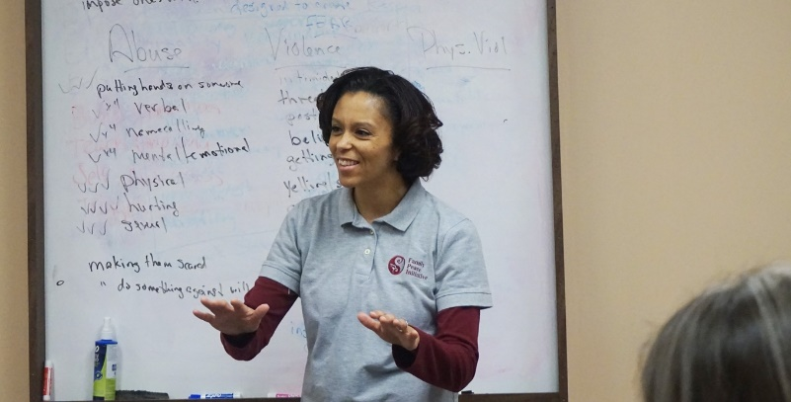](https://www.familypeaceinitiative.com/images/site/Tish-Good.jpg)Ending cruelty in a relationship requires taking some difficult yet rewarding steps.  We consider the goals for those who are engaged in FPI to be two-fold. We call these goals the steps of Getting out of the “River of Cruelty”.  Getting out of the river requires that each person be responsible for:

1. All of the cruelty that the participant has done to others, and
2. Taking responsibility for healing the impact of the cruelty that was done to them long before they were old enough or big enough to be able to do anything about it.

Trauma and adverse experiences are never an excuse for cruel, abusive behavior.  It is however, a common ingredient in the creation of a person who inflicts cruelty on others.

Ending cruelty in a relationship requires taking some difficult yet rewarding steps.  We consider the goals for those who are engaged in FPI to be two-fold. We call these goals the steps of Getting out of the “River of Cruelty”.  Getting out of the river requires that each person be responsible for:

1. All of the cruelty that the participant has done to others, and
2. Taking responsibility for healing the impact of the cruelty that was done to them long before they were old enough or big enough to be able to do anything about it.

Trauma and adverse experiences are never an excuse for cruel, abusive behavior.  It is however, a common ingredient in the creation of a person who inflicts cruelty on others.

[**Our Approach**](javascript:void(0);)

Our “River of Cruelty” model of batterers’ intervention is an approach that incorporates trauma-informed care into the standard cognitive-behavioral approach.  One of the primary efforts of this approach is to engage with participants in an emotional space.  This affective component works in depth with the fear, grief, anger, and sadness that men bring into the program.   We carefully train our facilitators for over a year before they become equipped to facilitate a group for us as the primary facilitator.  There is a great deal of expertise required to do this type of work, as we ask our staff to lead by example. They must all be able to do whatever we ask the participants to do, and do it better. This is a very tall order that is not for everyone.

One of the central components of this approach is a technique called “The Shadow Process”.  This is often a highly emotional process that digs deep into the roots of the attitudes and beliefs that we all hold about ourselves.  We connect this process to control logs, and the breaking down of any event that participants bring into the room that has an emotional load attached to it. This process quickly moves a conversation regarding any emotional reactivity about a person, to a conversation about our dangerousness and the link to past traumas.

Those who use violence, as a group, have experienced large numbers of adverse events, or traumas long before they became cruel themselves.  We routinely deal with these issues in our group rooms.  From physical to sexual abuse, emotional cruelty and abandonment, these traumatic events are routinely discussed and processed.  We work hard to connect the “river of cruelty” from the cruelty they have experienced to the cruelty they have done to others.  It must be emphasized at this point that cruelty experienced is NEVER an excuse for cruelty inflicted upon others.  Inflicting cruelty on someone else is simply evidence that one has not been completely responsible for healing the impact of the cruelty experienced.  Once we heal that impact, we stop passing cruelty on to others.

### [Connection Between DV Motives and Human Trafficking](javascript:void(0);)

In this audio recording, Dorthy explains the different motives of those who batter and the connection to Human Trafficking.

## History

The Family Peace Initiative (FPI) is a certified batterers intervention program operated by Halley Counseling Services, P.A. Presently, FPI operates 11 groups in 4 communities throughout eastern Kansas. Along with direct service, the staff of the FPI conduct trainings through workshops and conferences focusing on batterers intervention facilitation and batterers motivation.

FPI was born out of the work of Dorthy Stucky Halley, MSW, and Steve Halley, LSCSW. Dorthy received grant funding for a batterers intervention program in the earky 1990’s. In 2002, significant program changes occurred and FPI was born. A new curriculum was created and a new focus on intervention was undertaken that was research and evidence based.

In 2007 the Department of Corrections (DOC) and the Kansas Coalition against Domestic and Sexual Violence (KCSDV) along with the Topeka YWCA, invited Halley Counseling to participate in a pilot project focusing on people who were on parole for domestic violence offenses. The project was terminated as a result of the economic crash 2008. At that time, Halley Counseling and the YWCA agreed that the program would be maintained and worked together to keep the Family Peace Initiative in operation.

Today: FPI not only operates 11 classes in 4 communities throughout the eastern part of Kansas, but also operates the Peaceful Families Program in the Topeka Correctional Facility. In addition, FPI consults with the Kansas Department of Corrections, assisting in establishing a batterer intervention program in prison facilities and parole offices.

Along with direct service, the staff of the FPI conduct trainings through workshops and conferences around the midwest focusing on batterers intervention facilitation and batterers motivation. The Family Peace Initiative Training Series has been established to advance the skills of those who facilitate batterer intervention programs. Our “Cracking The Code” workshop has brought a new understanding to the field of domestic violence as to the motivations of those who batter.

## Motivations of Those Who Batter

**MOTIVATIONS OF BATTERING**

**Dorthy Stucky Halley, LMSW**

**SURVIVAL BASED:**Batterers who are motivated by this are commonly abusive when the relationship is approaching an end.  It is not surprising to find little or no abuse except when the batterer believes that he is about to lose his partner: then desperation peaks, with rage and terror.  This type of person is unable to imagine life being meaningful without their partner. They also cannot imagine their partner being with someone else. Suicide/homicide cases concerning DV are often Survival Based.

**ENTITLEMENT BASED:**These batterers hold beliefs of superiority and privilege over their partner.  They commonly batter to punish their partner for "stepping out-of-bounds", or when expectations are not met.  There are two sets of rules for partners in these relationships: the entitled batterer has the privilege, while the partner has the responsibility.

**SADISTIC BASED:**These batterers tend to use cruelty as a form of pleasure for themselves: they gain enjoyment out of causing pain and suffering to their partner.  Their sadistic ways are often unknown until long after the marriage vows.  Typical red flags for battering behavior are commonly missing in the dating relationship, as sadistic abusers are often calculated and cunning.

**NOTE:**These categories don’t reflect the complexity of individuals.  It is possible for a batterer to have characteristics of more than one type.

## Batterer Motive and Human Trafficking

In this interview Dorthy explains the different motives of those who  batter and the connection to human trafficking. Kansas victim service agencies have found, in cases where the agency could identify the connection between the trafficker and the victim, over 1/3 of the victims where trafficked by their partner.  This is commonly not discussed in domestic violence or human trafficking circles.  Our awareness of this phenomenon, along with an understanding of the different motives of batterers, can help identify victims and respond to their needs.

[**FPI Batterers Intervention Program**](javascript:void(0);)

[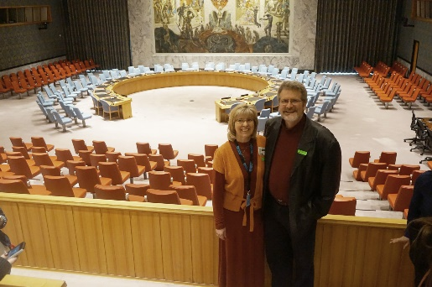](https://www.familypeaceinitiative.com/images/site/Dorthy-and-Steve-security-Council.jpg)Our batterer intervention program is a minimum of 26 weeks in duration. The course includes an initial Assessment, an orientation class and 24 weekly group sessions.

**Topics covered within the Family Peace Initiative curriculum include:**

* Cruelty vs. Respect
* Integrity and Accountability
* Personal Introspection
* Negotiation and Fairness
* Trust and Partnership
* Parenting with Respect
* Sexual Respect
* Healthy Family Relationships

### [The Peaceful Families Prison Program](javascript:void(0);)

### A Trauma-informed Program for Incarcerated Women

Description:  The Peaceful Families Program PFP was created in 2015 as part of the recognized need to help justice involved women to address:

1. Impact of trauma on their lives
2. Reduce behavior challenges within the prison setting, and
3. Decrease recidivism among those who are released back into the community

Originally implemented as a pilot project, the Peaceful Families Program was developed using the Family Peace Initiatives “River of Cruelty” approach to trauma intervention. It  has expanded from the first original group of 9 women to 3 groups that each meet 2 times per week for 2 hours per session.

PFP is a voluntary, 6-month program that operates in a closed group fashion. Groups consist of 8 to 12 women. Participants can be referred by corrections staff, or personally request the opportunity to get involved. There is currently a waiting list at the Topeka Correctional Facility for entrance into PFP.

**What people are saying about the Peaceful Families Program:**

“I feel relief, deep healing, love,  trust, I am good enough, and not angry… This groups has been the best thing that has happened for me.”

—A Graduate

“This class has taught me to see how the action or words of others can trigger the shadows that drag me into that “River of Cruelty”. Instead of acting in a negative way… I know I can deal with those people and things they say or do to me in a positive way.”

—A Graduate

"It was a lesson in life for me. My inner self was the focus not just my mind, but my heart, my spirit, my self-worth.”

—A Graduate

“This class has taught me to have boundaries in every kind of relationship. I have become a better person.”

—A Graduate

“For the past 10 years, I have helped facilitate a self-help group at the women’s prison in Topeka, Kansas…All but a few of its members have experienced debilitating levels of emotional, physical, and sexual trauma.

Some of the members have taken the Peaceful Families class.  I don’t know what goes on over there, but I do know that the program’s graduates come back different. They are calm, thoughtful, ready to rebuild, and anxious to do something positive with their lives.”

—Dave Ranney, volunteer,   
Reaching Out From Within Program

“Every person on my caseload who has ever been involved with Peaceful Families has commented on how much they have had to “dig deep” inside themselves. This not only serves as a vehicle for introspection and self-exploration but has had the effect of making them more willing and open to further self-exploration.

In my opinion, this curriculum gives a multi-layered gift to the individual and in turn the facility by giving them the opportunity to begin to learn and secondarily, whetting their appetites for more growth.”

—Deb Alexander, Unit Team Leader, KDOC

**Curriculum Description**

* Designed as a strong mix of cognitive-behavioral and affective components
* 8 sections; generally 3 weeks per section
* Focus on the River of Cruelty

**Facilitation Style and Skill**

* Emotionally capable to lead by example
* Trauma-informed
* Understand Gender-Responsivity

**Philosophical Approach**

* Compassion, Integrity, and Expertise

[**Consultations**](javascript:void(0);)

Halley Counseling Services, P.A offers consultation in the following areas:

1. Batterer Intervention Facilitator Supervision/training
2. Program development and design
3. Becoming a certified BIP in Kansas
4. Victim/partner work in BIP
5. Batterer Intervention in the Prison Setting
6. Trauma informed Programming for incarcerated women

# The Batterer Intervention Facilitator’s Tool Box

[](https://www.familypeaceinitiative.com/blog/subscribe-to-our-blog)

**Welcome to our blog**. These posts share some of the many tried and true tools, skills, and techniques that the Family Peace Initiative has found to be valuable through the years. We hope that this Facilitator's Tool Box will become a resource for you in your own quest to be the best facilitator you can be. We will be adding new blog posts monthly. Enjoy!

## The Folly of "Fixing" Those Who Batter

* [Email](https://www.familypeaceinitiative.com/component/mailto/?tmpl=component&template=gantry&link=2d0416e8ea0c0770ab88220ebca595ef01b18952)

Last Updated: Monday, 14 October 2019 16:25

Written by Steve Halley

I remember, all too well, my early days as a battering intervention facilitator.  I took my job very seriously.  I focused on holding those in my classes accountable. I listened very closely to how they blamed their partner, minimized their behavior. If I ever heard the participants refer to their partner as “my old lady” or, “my old man”, I would demand they use names, pointing out that their language was just another way to dehumanize their victims.   I learned the language of a facilitator and I used that language well in my classes.   I was going to “fix” those who battered and in doing so, was going to protect victims of domestic violence.  I did not understand that my way of thinking said more of my immaturity than about those I was serving, and probably did little to protect anyone.

I remember the first time I was introduced to the idea that maybe those who batter are not in need of being fixed.  Maybe they weren’t broken. Maybe, instead, people who have used violence in their families needed help in healing.

[Read more ...](https://www.familypeaceinitiative.com/blog/404-the-folly-of-fixing-those-who-batter)

## Anger Management: Barking up the Wrong Tree

* [Email](https://www.familypeaceinitiative.com/component/mailto/?tmpl=component&template=gantry&link=f479b9d735b10a0c701b788bf21d7b53c411e187)

Last Updated: Tuesday, 03 September 2019 19:53

Written by Steve Halley

People commonly come to battering intervention programs thinking they needed help with managing their anger.  Many have taken anger management classes in the past, but the problem continued.  I normally listen as they explain many of the ways their anger has disrupted their lives.  They believe that if they could get a handle on their anger, life would get better.  Eventually, I explain that I have some good news and some bad news for them. The good news is that while I have met many who believe they have anger issues, I have never met anyone who actually did have an anger problem.  The bad news is that the real problem is much more difficult than addressing “anger”.  I offer that If we are going to address this problem, we are going to have to talk about what the anger is protecting. We are going to have to talk about fear. Addressing an anger problem without addressing fear is literally like barking up the wrong tree.

Anger is commonly defined as a response to a perceived threat to either one’s self or others. Therefore, by definition, anger is a response to fear.  Battering behavior is never a result of an anger problem.  Battering behavior is a pattern of behavior desigend to  dominate and control another. There are plenty of other tactics that serve the purpose of dominating and controlling another. Anger is just one of many.

[Read more ...](https://www.familypeaceinitiative.com/blog/403-anger-management-barking-up-the-wrong-tree)

## Having Fun in Battering Intervention Classes

* [Email](https://www.familypeaceinitiative.com/component/mailto/?tmpl=component&template=gantry&link=6672ecbce4b0aa11cc23abe0edf7b10e040f412d)

Last Updated: Monday, 15 July 2019 16:24

Written by Steve Halley

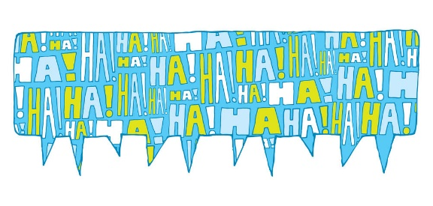

Working with those who batter is serious work.  The damage that domestic violence inflicts on partners, children, extended family and friends is no laughing matter.  However, in the effort to help people change, humor can help[.  Building relationships](https://www.scottdmiller.com/what-works-in-psychotherapy-valuing-what-works-rather-than-working-with-what-we-value/) has been shown to be the single most powerful tool in the helping professions, and one of the most powerful tools in relationship building is laughter.  With the best of intentions, groups facilitators put on the “accountability mask” week after week, creating a group experience that is serious and can be intimidating and unenjoyable to those we are trying to help.  Change can be a painful process, but it does not have to be painful all the time.  Facilitators become better at their craft when they can incorporate fun working with those who batter.

[Read more ...](https://www.familypeaceinitiative.com/blog/402-having-fun-in-battering-intervention-classes)

## Getting past the “Cover Story” in Battering Intervention

* [Email](https://www.familypeaceinitiative.com/component/mailto/?tmpl=component&template=gantry&link=a63c1695a76632dbc39b7592d0bedce4deb4e670)

Last Updated: Wednesday, 19 June 2019 14:29

Written by Steve Halley

I recently read about the challenges facing veterans returning from war.  Many had lived through unimaginable trauma during their service…experiences that will likely remain engraved in their memory for life.  Often, veterans, like other victims of trauma, create stories upon their return, based on truth, that can be shared with family and friends without too much emotional risk.  Soldiers do not have to go into details and reexperience the emotional intensity of their entire story. They can remain safe in their retelling of their “cover story” without having to risk emotional activation and the stirring of their traumatic memories.

Participants in battering intervention programs have cover stories too.  It is often too vulnerable for participants to initially acknowledge and be accountable for, not only the violence bestowed upon their partner and children, but also the violence and cruelty that had been bestowed upon them long before they could do anything to be safe.  While the cover story is designed for psychological safety, part of the change process is to help move the conversation beyond the cover story, toward genuineness on a deeper level.

[Read more ...](https://www.familypeaceinitiative.com/blog/401-getting-past-the-cover-story-in-battering-intervention)

## Addressing Battering Behavior and Childhood Trauma

* [Email](https://www.familypeaceinitiative.com/component/mailto/?tmpl=component&template=gantry&link=c5a454225313211499cb126cd3d3c846c2d8278a)

Last Updated: Tuesday, 28 May 2019 19:40

Written by Steve Halley



Battering intervention is changing.

Recent neurobiology findings show that early trauma experiences literally change the brain.[The Adverse Childhood Experiences](https://www.cdc.gov/violenceprevention/childabuseandneglect/acestudy/index.html) study (ACE) has provided us with insight regarding the impact of family dysfunction through the lifespan.   Adverse experiences have been linked to a wide variety of difficulties, including increased dysfunctional behaviors, chronic health conditions, low life potential, and even early death. One noteworthy finding of this study is the more adverse experiences one has, the more likely a person will use violence against their partner. Battering behavior is, unfortunately, all-too-common when one has childhood experiences of family dysfunction and other forms of cruelty. It is time for facilitators to integrate this information into our approach.

[Read more ...](https://www.familypeaceinitiative.com/blog/400-addressing-battering-behavior-and-childhood-trauma)

## Battering is a Choice, But...

* [Email](https://www.familypeaceinitiative.com/component/mailto/?tmpl=component&template=gantry&link=429b67e4895a7112bcc2ad5272941ec790295ada)

Last Updated: Wednesday, 10 April 2019 04:36

Written by Steve Halley



I remember listening, as a passionate intern got frustrated with a group member and blurted out, “Battering is a choice...a simple choice. It is not hard to make another choice. People can simply choose to stop battering!” I watched, as most of the men in the group mentally “checked out”. I shook my head and smiled, remembering how I had wanted the change process to be simple in my early days of this work.  Describing battering behavior as a choice, while true, is an oversimplification that does little to help those who batter choose differently. This intern needed to understand some of the driving forces behind “why”, as well as “who” makes violent choices in relationships.

[Read more ...](https://www.familypeaceinitiative.com/blog/399-battering-is-a-choice-but)

## Let's Stop Sending DV Victims to Battering Intervention Programs

* [Email](https://www.familypeaceinitiative.com/component/mailto/?tmpl=component&template=gantry&link=c4ada11462b27c81d42f3edd139ba2260c0c60a9)

Last Updated: Wednesday, 20 February 2019 17:41

Written by Steve Halley

Look no further than a judge in Kansas determining that a 13 and a 14-year-old girl were “aggressors” when they had sex with a 67-year-old man to understand that our legal system can really screw things up. We see this happen often in domestic violence cases: a victim of domestic violence uses some form of illegal violence in a situation that leads to their arrest.  This use of illegal violence is not the same as “battering”, as that term requires an ongoing pattern of domination and control of a partner.  Without examining context and patterns, victims of domestic violence are often arrested, charged, plead or are found guilty and then ordered to complete a battering intervention program. It seems obvious, but victims of domestic violence, even if they use illegal violence, should never be sent to a battering intervention program (BIP).

[Read more ...](https://www.familypeaceinitiative.com/blog/398-let-s-stop-sending-dv-victims-to-battering-intervention-programs)

## The Roots of Entitlement in Domestic Violence

* [Email](https://www.familypeaceinitiative.com/component/mailto/?tmpl=component&template=gantry&link=a641f59b4251102b51cb86c696326af815d57c7c)

Last Updated: Tuesday, 08 January 2019 04:05

Written by Steve Halley



If you have led domestic violence groups, you have surely had conversations about entitlement.  It is common to hear group participants discuss entitlement beliefs and attitudes such as, “I am in charge because I am the man”, or “I make the money, so I get to decide how it’s spent”.  Facilitators have been coached through the years to help participants examine these entitled beliefs to help participants pursue a more equal, non-violent relationship.  While entitled beliefs are commonplace in intervention classes, facilitators do not often recognize how these beliefs can come from different sources.   Understanding the different roots of entitlement can be useful in intervening with those who batter and can help to elevate safety for those living with an abusive individual.

[Read more ...](https://www.familypeaceinitiative.com/blog/397-the-roots-of-entitlement-in-domestic-violence)

## Moving Beyond Accountability for Those Who Batter

* [Email](https://www.familypeaceinitiative.com/component/mailto/?tmpl=component&template=gantry&link=0179dd1b9d5b537ab984e8bbe5f01e3f0586a240)

Last Updated: Tuesday, 27 November 2018 01:23

Written by Steve Halley



If you have worked within the movement to end domestic violence for any length of time, you have heard the mantra, “Victim safety and batterer accountability”.  This mantra sums up the focus of the fight to end gender-based violence.  The proliferation of battering intervention programs was one of multiple ways the system has worked to establish “batterer accountability."  While accountability is a critical element for getting those who batter into our doors, and to keep them there, it is an unfortunate shortcoming for facilitators to rely on accountability as the primary focus of the intervention. It often requires much more to be effective.

I admit that early on in my career, I thought accountability was the answer in working with those who batter.  I wanted them to take complete responsibility for ALL their abusive behavior, and they were going to recognize the impact that their behavior had on their partner and children...whether they wanted to or not.  I saw myself as protecting women by holding participants of my program to a high bar, and I would be satisfied with nothing less.  I was going to get these men to change, as there was simply too much at stake to not.

[Read more ...](https://www.familypeaceinitiative.com/blog/395-moving-beyond-accountability-for-those-who-batter)

## “It is a Scary Time for Young Men in America”

* [Email](https://www.familypeaceinitiative.com/component/mailto/?tmpl=component&template=gantry&link=bf6668420cf13cb2d173907b6b90598a9cdc0409)

Last Updated: Sunday, 14 October 2018 21:34

Written by Steve Halley

I have been moved by the experiences shared by so many during the the recent  Kavanaugh hearings. However, I took pause when our President said, “it is a scary time for young men in America”. The argument is that Judge Kavanaugh has been the victim in the Senate proceedings, and now young men everywhere need to be afraid, as they, too, can be potential victims of false allegations. What struck me, however, is how many times I have heard this “victim” position claimed by perpetrators of domestic violence.

In domestic violence intervention classes, it is common for participants to initially use the defense of, “I’m the real victim here!” They argue that their partner is the one who was violent: “I was protecting myself and I was the one arrested!” They like to point out that if the police come to a domestic violence call, it is the man that is going to be arrested. We hear this frequently as people try to avoid accountability and present themselves in a positive light.  While there is no doubt that there is a rare case of someone being falsely arrested and convicted, the clear majority of those who claim this defense are guilty of the crime. In fact, the vast majority of those who were arrested, but not convicted, are also guilty—there just wasn’t enough evidence for a conviction.

[Read more ...](https://www.familypeaceinitiative.com/blog/394-it-is-a-scary-time-for-young-men-in-america)

## A Facilitators Worst Nightmare in Domestic Violence Intervention

* [Email](https://www.familypeaceinitiative.com/component/mailto/?tmpl=component&template=gantry&link=8e9eccf8b729a959ea02d47f9ff7d5cb1fd41889)

Last Updated: Wednesday, 12 September 2018 16:04

Written by Steve Halley

I remember him well.  He struggled at first in the batterer intervention class.  I believed he was trying.  He wanted his partner to come back home. She had left him after he had been arrested for beating her.  She was living with her parents.  He was seeing their kids on infrequent visits. He wanted his family back.  He knew he had to complete our class if he was going to have a chance to get what he wanted.

He was a charming, charismatic guy.  He had a sense of humor that he used often to make us all laugh.  People liked him.  He expressed concern for others and tried to be there when others needed him.  At the same time, he struggled to be accountable for his own cruelty in his relationship.  He liked to blame his partner for his violence.  He tended to make excuses for his violence.  He was afraid that he was going to lose his wife and kids.  He was not sure if he would have a reason to go on living if she ever decided to leave him for good.  He was desperate to do what he had to do to get his family back.  He had talked once in class about a heated argument with his wife because things were not moving fast enough for his liking. He just wanted her to come home.

[Read more ...](https://www.familypeaceinitiative.com/blog/393-a-facilitators-worst-nightmare-in-domestic-violence-intervention)

## “All Women are Bitches”

* [Email](https://www.familypeaceinitiative.com/component/mailto/?tmpl=component&template=gantry&link=cab83e692c82c3fdb26e76824cee36f1ca3ed43d)

Last Updated: Friday, 17 August 2018 12:34

Written by Steve Halley



I was completing an initial assessment with a young man who had been referred to our battering intervention program. He clearly did not want to be there, but he was doing his best to show that he would cooperate.  His answers were short, to the point and he came across as angry in his general demeanor.  When I asked him for basic information about his partner, he called her a “bitch” and said that he did not really want to talk about her.  When I asked him questions about his mother, he again, used the term “bitch” and described qualities that he did not like about her, including the fact that she had left him when he was young. I decided to dig deeper, so I pointed out to him that I had only asked him about two women in his life and he had described both as “bitches”.  I asked him if he felt that way about women in general or was it only these two.  He jumped out of his chair startling me. He took off his shirt and turned to show me his back.  Tattooed in large bold letters across his shoulder blades was “All Women Are Bitches!”  He then turned back toward me and said, “Any more questions?”

[Read more ...](https://www.familypeaceinitiative.com/blog/392-all-women-are-bitches)

## The Victim Who Lied...and Changed My Work Forever

* [Email](https://www.familypeaceinitiative.com/component/mailto/?tmpl=component&template=gantry&link=86ead9864315c6fd651f2af48cd5167a5e3a58b4)

Last Updated: Saturday, 07 July 2018 03:14

Written by Steve Halley

I must admit that when I entered private practice I thought I was on my way.  I was a trained therapist.  I was going to focus my practice on individual and couples counseling, with a little batterer intervention on the side.  I had been trained through graduate school and supervised practice. I had learned how to diagnose mental health concerns and I had learned the fundamentals of a variety of therapeutic models.   My education was good, but I had no way of knowing what I did not know.  Looking back, there were so many things that I thought I knew, but…

When Sherry and Bill came to my office for couples counseling I had no idea what I was about to learn. They were an older couple, from rural Kansas where they had farmed together for most of their adult lives. Sherry did most of the talking while Bill listened.

[Read more ...](https://www.familypeaceinitiative.com/blog/391-the-victim-who-lied-and-changed-my-work-forever)

## Thoughts vs. Feelings...Chicken or the Egg?

* [Email](https://www.familypeaceinitiative.com/component/mailto/?tmpl=component&template=gantry&link=44626d11e1d0debd7e234a48f4d7ab0bcaeac2a1)

Last Updated: Tuesday, 15 May 2018 18:13

Written by Steve Halley



One topic that seems to get considerable discussion among BIP facilitators is "the chicken or the egg" conversation regarding "thoughts or feelings". The discussion centers around which approach is better. While there are plenty who would argue that focusing on "thinking and beliefs" impacts feelings and is the best approach, there are others who vehemently argue the focus must be first on feelings. The Family Peace Initiative would say that there really is not a "chicken or egg" conundrum on the topic.  A facilitator needs to have the ability to work with both thoughts and feelings with those they serve. The inability to do so limits the effectiveness of BIP work. A better question to be asked is not whatto focus on, but "how" do we focus on both simultaneously.

Commonly, participants in BIP classes have strong beliefs about emotions.  Participants will say how they were taught to avoid expressing sadness and fear in their childhood. It is normal to hear comments like, "My step-dad told me that he would give me something to cry about if I kept crying", or, "If people knew that I was afraid, they would think I was weak and would take advantage of me".  Participants live in fear of being seen as weak, soft, and unmanly. They mask this fear through aggression, addiction, and a host of other defense systems.

[Read more ...](https://www.familypeaceinitiative.com/blog/390-thoughts-vs-feelings-chicken-or-the-egg)

## Excellent Victim Services Will Not Stop Domestic Violence

* [Email](https://www.familypeaceinitiative.com/component/mailto/?tmpl=component&template=gantry&link=da64eebfebe22f7c1681c272c28fe79b00c3f051)

Last Updated: Sunday, 08 April 2018 22:46

Written by Steve Halley



In 1989, my wife, Dorthy, was serving as the Director for a shelter program for women trying to escape partner abuse. When she realized that her agency had served the 7th victim of the same abusive man, she recognized that something had to change in society’s response to domestic violence. While serving victims effectively is critical for their and their children's well-being, serving victims after they have been abused will never end domestic violence.  Dorthy knew that getting the abuser to change was the only way to stop the violence. Her efforts to start a program for those who batter in those early years formed the foundation of what is now the Family Peace Initiative.

Since the movement to address domestic violence began, the focus has been on victim services. While there is a continuing need for additional money for victim services, battering intervention programming remains almost entirely unfunded. There are beliefs that contribute to this.  Here is a list of some:

[Read more ...](https://www.familypeaceinitiative.com/blog/389-excellent-victim-services-will-not-stop-domestic-violence)

## Promoting a Change of Focus in BIP

* [Email](https://www.familypeaceinitiative.com/component/mailto/?tmpl=component&template=gantry&link=f107bd2a19b6419e20e9d22b0a8b6bc4f34ac216)

Last Updated: Tuesday, 20 March 2018 13:58

Written by Steve Halley

I had the pleasure of listening to Chris Huffine present last November at the BISC-MI "Miles To Go" Conference in Michigan.  Chris has a remarkable skill of describing with clarity what he is trying to accomplish within his Allies in Change Program in Portland, Oregon. One topic that Chris discussed was the overall goal of helping move participants from an external focus to an internal focus. I wondered how many professionals listening to his presentation realized the importance of what Chris was saying.  Moving people from external to internal focus is exactly what we ty to accomplish at the Family Peace Initiative as change is unlikely to occur without this. It is an extremely important facilitator skill and may be one of the most challenging to master.

Dominating and controlling another, blaming and the anger that our participants often express, are all forms of external focus. Conversely, internal focus consists of managing, being fully aware of, and being accountable for oneself.  Chris Huffine talks about the need to help participants become aware of the emotions behind the anger.  He teaches that anger is seen as some other emotion plus blame. Helping participants examine the "some other emotion" without the blame helps them to move toward a calmer, less reactive internal focus.

[Read more ...](https://www.familypeaceinitiative.com/blog/388-promoting-a-change-of-focus)

## How Do I Start? The Group Check-in

* [Email](https://www.familypeaceinitiative.com/component/mailto/?tmpl=component&template=gantry&link=8cd4e0bb6e66e6e94e99c9428fd37f260a265717)

Last Updated: Thursday, 22 February 2018 22:57

Written by Steve Halley



John Gottman says that the way an argument is started helps determine the way it will end. I believe that the same is true for battering intervention program groups: a good beginning can influence how the group ends. I have to confess, when I started doing this work, I didn’t give much thought to how the group started. It was only after I was involved in this work for a while that I noticed the impact of the start-up, whatever it might be. I hear of some programs using mindfulness activities to begin classes, with good results. One man told me of meditative readings that he uses to set the tone for his group. While there are countless approaches to beginning a group process, I’ve noticed that quite a few of us use a version of “check-in” to start group--but the purpose and way it is administered varies greatly.  After trying to use the check-in in a variety of ways, we’ve found a relatively simple version gives both facilitators and participants good results, but for different reasons.

[Read more ...](https://www.familypeaceinitiative.com/blog/387-how-do-i-start-the-group-check-in)

## Beliefs Can be Beautiful Doorways to Change in BIP

* [Email](https://www.familypeaceinitiative.com/component/mailto/?tmpl=component&template=gantry&link=1d21718db7914d04183a3f591bdd66fcba30542b)

Last Updated: Tuesday, 16 January 2018 16:53

Written by Steve Halley

Much the way a vehicle is propelled by a motor, in many ways, people are propelled, or “driven” by beliefs.  Rarely do we make a choice of what we say, do, or not do, without a belief “driving our car”. A central aspect of many batterer intervention programs is bringing the beliefs that serve to "justify"  cruel behavior the surface. Examples of these beliefs include, " I am the man, so I am the boss" or, "When I am violent, it is because she pushed my buttons".  Many group facilitators have been trained in the cognitive behavioral strategies for identifying these beliefs, and discussing them with participants. However, when using a trauma-informed affective approach, these moments can be used to accomplish even more.

[Read more ...](https://www.familypeaceinitiative.com/blog/386-beliefs-can-be-beautiful-doorways-to-change)

## The "Ping Pong Effect" in Batterer Intervention

* [Email](https://www.familypeaceinitiative.com/component/mailto/?tmpl=component&template=gantry&link=31770d713d279c1df869461d4e890f37ec61f217)

Last Updated: Monday, 18 December 2017 00:09

Written by Steve Halley

It is no longer surprising to me when a participant discloses he was angry when he was first told he needed to attend a battering intervention program. It is common among those we serve. It still puzzles me that a person can be violent and cruel to their partner and not recognize the need to work on changing their own behavior.  Thank goodness, most of our participants change their perspective over time.  One of the helpful ingredients to make this change happen is something we call the “Ping Pong Effect”.

When discussing the process of change with those who complete our program, they commonly acknowledge the frustration and resentment they held when they first arrived. When reflecting on what helped them to move beyond this, they frequently refer to the stories that were shared by others in the group. They will say something like, “Once I learned that there are other people who are like me--in a strange way, I felt better. I realized I was not alone.”

[Read more ...](https://www.familypeaceinitiative.com/blog/385-the-ping-pong-effect-in-batterer-intervention)

## Thoughts on Sexual Respect

* [Email](https://www.familypeaceinitiative.com/component/mailto/?tmpl=component&template=gantry&link=1b5a72f4881d5f2c65e524428a3c766d7f0402d0)

Last Updated: Tuesday, 28 November 2017 17:50

Written by Steve Halley

If you have been paying attention to the news lately, you have heard many women who have been sexually assaulted speaking out publicly. If you are familiar with the #METOO thread, you know that nearly 1.5 million women have acknowledged that they have been victims of rape, sexual abuse and sexual harassment. This should not be a surprise, as research has indicated this prevalence for a long time. Dr. Mary Koss completed a study at Kent State in the 1990’s that showed almost one third of American women, by the time they reach age 25, will have experienced rape, or attempted rape.    What often goes unspoken is the number of men—likely millions, who are sexually assaulting women. Some of these men who sexually disrespect women walk into our BIP classes each week.  Sexual respect is a topic BIP programs can't afford to ignore.

[Read more ...](https://www.familypeaceinitiative.com/blog/383-thoughts-on-sexual-respect)

## Interns Experience the FPI Orientation

* [Email](https://www.familypeaceinitiative.com/component/mailto/?tmpl=component&template=gantry&link=9f79a043be872648b5fd966585d3df84160ea144)

Last Updated: Friday, 20 October 2017 15:35

Written by Steve Halley

Welcome to the first edition of the Family Piece Initiative (FPI) Intern’s Blog. This blog will be written by Katie Z. and Anna K., both social work interns, who will be spending the next nine moths learning how to intervene with those who batter. It is our pleasure to share with you some of our learning experiences as we pursue the knowledge and skills to become facilitators for a batter intervention program (BIP).

The first significant lesson we learned at FPI was through an orientation class. Orientation is the first class that participants attend during their 27-week program. We were invited to engage in the class alongside participants who had been court-mandated to the program. Shortly after this class began, it became obvious that we were going to be asked to become vulnerable and take ownership for our own cruel behaviors, exactly what we ask of our participants.  Somehow, in what seemed like just a few minutes, the facilitator had all of us sharing things about ourselves that we wouldn’t normally share in every day conversation. Her approach seemed so natural, but we are still not sure how she so easily got us to open up.  It was sobering for us to participate in a process that asked us to examine our own beliefs, attitudes, and adverse emotions. It became clear that the FPI journey to becoming a skilled facilitator begins with the ability to look at ourselves.

[Read more ...](https://www.familypeaceinitiative.com/blog/382-interns-experience-the-fpi-orientation)

## A Motive to Consider in the Case of Stephen Paddock

* [Email](https://www.familypeaceinitiative.com/component/mailto/?tmpl=component&template=gantry&link=366ad4283dcd6b89419267d835ce3f774889bb25)

Last Updated: Friday, 13 October 2017 13:16

Written by Steve Halley

Ten days after the horrific event, the answers to so many questions about Stephen Paddock’s motive for creating death and destruction in Las Vegas remain unknown.  USA Today: October 11, 2017, when referring to Sheriff Joe Lombardo, reported: “Lombardo told the Las Vegas Review-Journal that investigators have interviewed Paddock’s entire family, including his two ex-wives. He said the investigation is progressing, but that a motive for the shooting has not been determined.  We may never know,” Lombardo said, “All those things that you would expect to find, we have not found.”

As we watch the news unfold, there have been many predictions, not the least of which is that Paddock must be a batterer.  Some have seized the opportunity to declare that almost all of those who are terrorists battered their partner. The challenge with this thinking is that we haven’t refined our approach—it is as if every domestic batterer is prone to mow down others without provocation.  We know that domestic violence is common while murder is rare.  It is a mistake to think all murderers have the same motive, just as it is a mistake to think all batterers have the same motive.

[Read more ...](https://www.familypeaceinitiative.com/blog/381-a-motive-to-consider-in-the-case-of-stephen-paddock)

## The Man in the Mirror

* [Email](https://www.familypeaceinitiative.com/component/mailto/?tmpl=component&template=gantry&link=277aef647039b1e4d0bc15635fda00d61addc546)

Last Updated: Friday, 13 October 2017 02:35

Written by Steve Halley

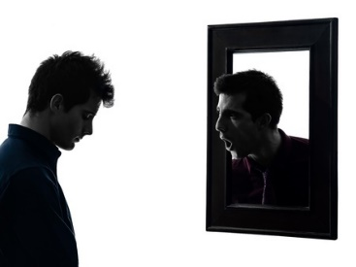

One of the men who completed the Family Peace Initiative program made a statement a while back that has really stuck with me.   He said, “I always thought that my job was to protect my family from monsters who might hurt them.  I will never forget the day I looked in the mirror and realized that the monster was not outside the house, but living inside the walls of our home. I realized for the first time that the monster was me.”  How is it possible that this man could be completely oblivious to the fact that he is “the monster” his family needs protection from?

[Read more ...](https://www.familypeaceinitiative.com/blog/380-the-man-in-the-mirror)

## It is All in the Message

* [Email](https://www.familypeaceinitiative.com/component/mailto/?tmpl=component&template=gantry&link=4e67678e162e1d4bf4caee3c195a2323d8ba4ae5)

Last Updated: Monday, 14 August 2017 15:56

Written by Steve Halley



In our approach to trauma-focused batterer intervention, we ask people to become responsible for two things:  1) The first is to be accountable for the cruelty that they have used against others; and 2) The second is to become responsible for healing the impact of the cruelty that was done to them long before they could do anything to prevent it.  The cruelty they experienced as a child can never be their fault, but they must take on the responsibility to heal the impact of those experiences. To show how these two components are linked, let me give you an example of how it plays out in routine conversations in our group room.

[Read more ...](https://www.familypeaceinitiative.com/blog/379-it-is-all-in-the-message-2)

## "Situational Violence" Rarely Is

* [Email](https://www.familypeaceinitiative.com/component/mailto/?tmpl=component&template=gantry&link=b1cd7837339e37e984bff2f4bd1d96ae5ed664ae)

Last Updated: Wednesday, 14 June 2017 03:29

Written by Steve Halley

Russ arrived at my office for his initial domestic violence assessment.  He had been arrested for domestic violence, and was seeking a diversion agreement with the district attorney.  As a condition prior to the diversion being granted, Russ was asked to complete a DV assessment with me.  He was a business owner in a small town.  He did not want this situation going to court because it could certainly heap embarrassment on him and his family, and impact his business.

I interviewed Russ for nearly two hours.  He began his assessment by telling me that he was completely embarrassed that he had hit his wife.  He explained that Bethany had an affair with a co-worker.  Russ confronted her shortly after he had found pictures of Bethany and the co-worker on her phone in a compromising situation.  The confrontation turned to yelling, and during the yelling, she stood up and pushed Russ.  Russ slapped her in the "heat of the moment", and Bethany called the police.

[Read more ...](https://www.familypeaceinitiative.com/blog/377-situational-violence-rarely-is)

## The Completion Letter

* [Email](https://www.familypeaceinitiative.com/component/mailto/?tmpl=component&template=gantry&link=75dd0b9b8e7cd17e703f132b91652768ef498875)

Last Updated: Tuesday, 23 May 2017 03:08

Written by Steve Halley

Learning styles vary among those who attend BIP classes.  The more activities used that relate to different learning styles, the stronger the BIP curriculum. One activity that we use is the Completion Letter. As the name describes, this is a letter that is written and presented by the participant to the class at the end of the program. This assignment carries with it the expectation that it will be a demonstration of what was learned throughout the 27 weeks.  The following example was recently read in class as part of a completion process. Of course, the names have been changed:

[Read more ...](https://www.familypeaceinitiative.com/blog/376-the-completion-letter)

## Domestic Violence is Child Abuse

* [Email](https://www.familypeaceinitiative.com/component/mailto/?tmpl=component&template=gantry&link=76aa534e9a1be942cd94954bef92c15eae5f511a)

Last Updated: Tuesday, 18 April 2017 19:33

Written by Steve Halley



"Bob” sits in class talking about the cruelty that he used against his wife.  He acknowledges yelling at her, calling her names, and on several occasions, punching and pushing her down.  The rest of us sit quietly, listening to his effort to take ownership of his violence.  As he gets close to the end of what he wants to say, he makes a comment that I have heard far too many times among those who use violence in their families.  Bob says, “as bad as I have been to my wife, at least I have never been abusive to my kids.”

I can’t think of a better example of denial than what “Bob” just said.  As if he can separate out his violence in the home and play like it only impacts one person.  Whenever there are children, abusive behavior towards “my wife”, is child abuse.  It is impossible to abuse a partner without abusing the kids. A parent is not a “good parent” if they are abusing their children’s other parent.  Period.

[Read more ...](https://www.familypeaceinitiative.com/blog/375-domestic-violence-is-child-abuse)

## The "Mantra of Shame" in Domestic Violence Intervention

* [Email](https://www.familypeaceinitiative.com/component/mailto/?tmpl=component&template=gantry&link=9f0d33fd15db9498cd04829008051293c214ccff)

Last Updated: Tuesday, 18 April 2017 17:24

Written by Steve Halley

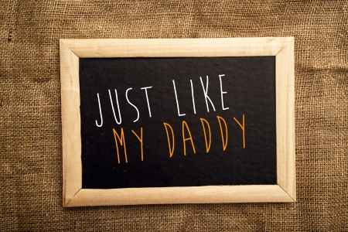

If you have been doing work with those who batter for any length of time, it is likely that you have heard the “mantra of shame”.  It usually comes unexpectedly. The mantra normally begins with a sigh, and then the eyes shift toward the floor. There is a pause and then the words come, barely audible.  “I promised myself…… I swore that I would never become… I vowed that I would never be… like my dad… and look…I am just like him.”  Tears often follow.

I have heard this mantra of shame numerous times.  This mantra is loaded with the emotional energy of sadness, fear, anger and profound grief for both the suffering of the past and the reality of present day.  It is a humbling moment when those who batterer realize that they have recreated the horror and trauma of their own experience. They have found themselves face to face with their own “River of Cruelty”.

[Read more ...](https://www.familypeaceinitiative.com/blog/374-the-mantra-of-shame-in-domestic-violence-intervention)

## Handing off the Football: Fear in Batterer in Batterer Intervention

* [Email](https://www.familypeaceinitiative.com/component/mailto/?tmpl=component&template=gantry&link=79e6512a1426cff672af3eb3afce6adfca016d53)

Last Updated: Wednesday, 15 March 2017 16:14

Written by Steve Halley



I remember playing “tackle the man with the ball” during recess in 5th grade. I hated this game. I didn’t mind “tackling the man with the ball” but I was terrified of being the one getting tackled. I did not want my classmates to know I was afraid, so occasionally, I would muster the courage to grab the ball and run. The blood thirsty mob would join in pursuit, and just as I was about to be tackled, I would throw the football over my head, high up into the air, and someone else would pick up the ball and run.  I had effectively given my fear away to someone else.

My work with those who batter reminds me of “tackle the man with ball”.  Many who batter go to great lengths to look brave, courageous or manly, but when the façade wears thin and fear becomes intolerable, anger, violence and threats are useful tactics to hand off the fear to others “like a football”. This need to give adverse feelings away to others is a direct result of growing up in “The River of Cruelty” where fear is considered weakness.

[Read more ...](https://www.familypeaceinitiative.com/blog/373-working-with-fear-in-batterer-in-batterer-intervention)

## "Only When I Deserved It": Those who batter and corporal punishment

* [Email](https://www.familypeaceinitiative.com/component/mailto/?tmpl=component&template=gantry&link=b8758195259f33305fca4f0be45cda5e7711f9ec)

Last Updated: Wednesday, 15 February 2017 17:47

Written by Steve Halley



Here in Kansas, everyone who gets referred to a batterer intervention program undergoes an assessment prior to engaging in the program.  One question we ask is how they were disciplined as a child. A few questions later, we ask about experiences of physical abuse.  The answers that people give to these two questions says a lot about how cruelty is passed from person to person and from generation to generation.

Commonly, when the question about discipline is asked, the answer goes something like…

“Oh, I was a bad kid growing up. I got whoopings all the time when I got in trouble.”

I follow up with a question like…

“What did a ‘whooping’ look like in your experience?”

[Read more ...](https://www.familypeaceinitiative.com/blog/372-only-when-i-deserved-it-those-who-batter-and-corporal-punishment)

## Maybe the Greatest Gift

* [Email](https://www.familypeaceinitiative.com/component/mailto/?tmpl=component&template=gantry&link=2e52c49b541c9740de9131ea3c319adc73db5190)

Last Updated: Tuesday, 20 December 2016 04:03

Written by Steve Halley

If you are not familiar with Yoda from the movie Star Wars, you are missing out.  In this movie, Yoda comes to the aid of Luke Skywalker who has crash-landed on a mysterious planet. Yoda earns Luke’s trust and trains himto be a Jedi Knight. Yoda eventually helps Luke to use his new-found powers to pull his spaceship out of a quagmire. Now, Luke is ready to do battle with Darth Vader and the dark side!  Without Yoda, Luke would have had a problem that would have seemed impossible to solve. He certainly would not have been prepared to battle Darth Vader. Figures like Yoda are examples of “enlightened witnesses”. This is a term Alice Miller used to describe the important people who guide us, teach us and accept us at critical moments in our lives.

[Read more ...](https://www.familypeaceinitiative.com/blog/371-maybe-the-greatest-gift)

## A Missing Piece in Batterer Intervention

* [Email](https://www.familypeaceinitiative.com/component/mailto/?tmpl=component&template=gantry&link=6e91f558b16705c9e84db8295075ab0d1b87f542)

Last Updated: Monday, 19 December 2016 16:13

Written by Steve Halley



Most batterer intervention programs work to help those who batter take responsibility for their abusive and cruel behavior.  This is believed to be a critical step in the process of change. At the Family Peace Initiative, we too, focus on this critical step.  However, over the years, we noticed continuing obstacles for many participants in being able to move toward responsibility. Often, these obstacles centered around the cruelty and trauma participants had experienced long before they became cruel to their partner. With this realization, we expanded what it means to be “responsible” to include responsibility for "healing the impact of the cruelty that was inflicted on them during childhood." Adding this dimension over 10 years ago seems like one of our most significant improvements in helping people become nonviolent. It is as if we found an important missing puzzle piece to our work.

[Read more ...](https://www.familypeaceinitiative.com/blog/370-a-missing-piece-in-batterer-intervention)

## Going to the Dark Side

* [Email](https://www.familypeaceinitiative.com/component/mailto/?tmpl=component&template=gantry&link=da61d0b5cf38325b81d1db38770aabb573cfdf9a)

Last Updated: Monday, 19 December 2016 16:14

Written by Steve Halley



At the Family Peace Initiative, we have several trained victim advocates on staff as BIP facilitators. They bring a knowledge of victim centered work and domestic violence dynamics that absolutely make us better. I was surprised to learn that advocates can pay a high price with their colleagues when they get involved in our work. They receive comments such as "What is making you go to the dark side?", like they are betraying victims by helping provide services to those who batter. Contrary to their colleagues' assumptions, many advocates report becoming better at their work with victims after they became skilled at working with those who batter.

[Read more ...](https://www.familypeaceinitiative.com/blog/369-going-to-the-dark-side)

## Looks Can Be Deceiving in Domestic Violence Intervention

* [Email](https://www.familypeaceinitiative.com/component/mailto/?tmpl=component&template=gantry&link=72200aa93052860ab7af54f43b2921cf845f5de4)

Last Updated: Monday, 19 September 2016 18:03

Written by Steve Halley

Different people can do the exact same thing for entirely different reasons.  Consider a Sunday morning church service. There might be 200 people in the service singing, praying, and listening to a sermon. While everyone looks like they are doing the same thing, they likely have different motives for being there. Some are probably there to commune with God. Others are there for the social interaction. Still others are there because their spouse or parent insisted. While all in attendance are seemingly doing the same thing this Sunday morning, their motives for being there vary widely.

The same is true for those who batterer. While all battering behavior is an effort to gain domination and control, understanding the motive that drives this quest for domination and control is crucial for effective intervention and safety planning. A "one size fits all" perspective reduces a program's effectiveness and can leave victims extremely vulnerable. The Family Peace Initiative has operated since its inception with an understanding of different motives of those who batter. Here is the way we break down the common motives among those who batter, and how the differences can impact their victims.

[Read more ...](https://www.familypeaceinitiative.com/blog/368-looks-can-be-deceiving-in-domestic-violence-intervention)

## The Power of Mixed Gender Co-facilitation

* [Email](https://www.familypeaceinitiative.com/component/mailto/?tmpl=component&template=gantry&link=40e6aa0678e0f78e5f9f4898bd15c48df5817fe3)

Last Updated: Tuesday, 16 August 2016 03:11

Written by Steve Halley

It was a memorable group session. The topic for the day was "Sexual Respect". Both Janet, my co-facilitator, and Sarah, in the early stages of training, were there with me. We commonly approach this topic by making a list of all of the ways that people can be sexually disrespectful. We work hard with the group to generate a large list of 35 to 40 behaviors that would be considered sexually disrespectful. Once the list is developed, we have everyone count the number of these behaviors that they have used in the past. We love making lists at the Family Peace Initiative, as it is a simple, yet highly effective way to get participants to acknowledge cruel behavior. This time, however, our making a list took the group in a different direction.

Janet had looked thoughtfully at the list of nearly 40 sexually disrespectful behaviors that we had just created with the group. She then commented in a surprised tone, “I just realized that I have experienced 33 of the behaviors listed here.” The group fell silent. Sarah calmly added that she, too, had experienced over 30 of the behaviors listed and only a few days ago had been sexually harassed at a stoplight with her young son in the backseat of her car. She went on to say, “I would say that most of my female friends have experienced over 30 of these behaviors as well.”

The men were surprised at how common sexually disrespectful experiences can be for women.

[Read more ...](https://www.familypeaceinitiative.com/blog/367-the-power-of-mixed-gender-co-facilitation)

## "Facilitator Error" and The Value of Introspection in BIP

* [Email](https://www.familypeaceinitiative.com/component/mailto/?tmpl=component&template=gantry&link=d4d3918222e5f76007f0b57c616b5df5902fc631)

Last Updated: Monday, 15 August 2016 00:13

Written by Steve Halley

### 47800946 s

Dick Mitchell, or “Chief Mitch” was the Director of a wilderness camp for emotionally troubled youth. I was fortunate that he chose to become a mentor for me while I worked at the camp. He believed in me, held me accountable when I strayed, made me laugh, played golf with me, and taught me how to be a better counselor. Often when I am facilitating BIP classes I get faced with situations where it is appropriate to employ a tool or strategy that I learned from “Chief Mitch”. While I wish I could remember more of his wonderful “pearls” of wisdom", the one that has been on my mind lately is a comment that he made to me over 25 years ago.

I was having difficulty figuring out how to get my group of 10 troubled kids to function well. My group was not accomplishing much and the kids in my care were extremely challenging in their behavior. I tried everything I knew to improve the situation, but nothing seemed to work. Out of frustration, I told Chief Mitch, "these kids are impossible!"

Chief Mitch came down to my campsite one afternoon to evaluate the situation. After spending a long, difficult afternoon with the kids and me, he said something like, “You know Steve, I think that probably 80% of the problems that happen in the groups around here are the result of counselor error. As counselors get better, problems seem to go away.” Then he walked away leaving me to puzzle over his words.

I think that Chief Mitch would agree with me when I say that probably 80% of the problems that arise in a BIP classroom are a result of “facilitator error”.

[Read more ...](https://www.familypeaceinitiative.com/blog/366-facilitator-error-and-the-value-of-introspection-in-bip)

## One Defining Moment

* [Email](https://www.familypeaceinitiative.com/component/mailto/?tmpl=component&template=gantry&link=8be9a96bfa91410024802452ec3f4438d4bb285e)

Last Updated: Wednesday, 15 June 2016 00:33

Written by Steve Halley

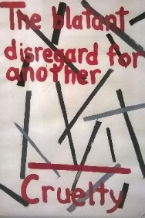I remember a domestic violence poster that I saw in the early 90’s. The poster showed the picture of a battered woman. Her face was bruised and swollen. The caption said something like, “If this is happening to you, call this number for help”.  In big bold numbers, the hotline number was inviting victims to call. When I started facilitating groups for those who batter, this poster represented my belief that our mission was to help protect women from being beaten up in relationships.

Every time we selfishly think of ourselves without considering the impact of our decisions on others, we have crossed the line into cruelty.

It did not take long before I recognized that my definition of abuse was entirely too narrow. Of course we want to help women, or men, who are being physically abused in relationships. However, there are plenty of other behaviors present in abusive relationships that are equally harmful, yet leave no tell-tale signs.  My focus on the physical types of “abuse” was counterproductive in working with those who batter, as it allowed them to avoid examining the full spectrum of their abusiveness. Working with the FPI staff, we examined our use of definitions. We thought about the impact of our definitions on those we served. We explored how the definitions invited introspection or created defensiveness.  We wanted a definition that encompassed the magnitude of the problem. Over the years, we've adopted some definitions, from other programs and from other sources, that have helped us immensely. Here are some of the definitions that have become central to our work:

[Read more ...](https://www.familypeaceinitiative.com/blog/365-one-defining-moment)

## The Value of Victim Contacts in Batterer Intervention

* [Email](https://www.familypeaceinitiative.com/component/mailto/?tmpl=component&template=gantry&link=f5ce920864f4767cd528535b9fc68570b2138a24)

Last Updated: Tuesday, 14 June 2016 15:10

Written by Steve Halley

### 



Len came into my office many years ago for a domestic violence assessment.  He had been arrested after an incident with his wife and was ordered by the court to complete the assessment and follow the subsequent recommendations.  I must admit that I was excited to have the appointment as I was just starting a BIP program in this particular community.  He was my very first referral there.  I had been in private practice for a few years, and had completed a fair number of assessments in other communities.  I have to admit that I thought I was pretty good at my work and I was ready to get this program up and running.

I was confident that this was an incident of situational violence where emotions had gotten out of hand.  Nothing indicated a pattern of domination that I was “expert” in detecting.

During my interview with Len, I was struck by how much responsibility he was taking for the incident.  He described how his wife, Michelle, had gone on a camping trip with some of her co-workers. She had been drinking most of the weekend and she ended up sleeping with one of her co-workers.  Len explained that he had learned of this after she returned home feeling guilty.  “I can always tell when she is lying to me.”  He said he had been stunned by the news as he never expected Michelle to “stray”.  He said that he overreacted and in the “heat of the argument,” slapped her. He had never hit her before and he felt horrible. He had apologized to his wife for his behavior but he could never recover from her cheating on him.  Len explained that they were in the middle of divorce proceedings. I listened intently, thinking I was pretty good at my work.

[Read more ...](https://www.familypeaceinitiative.com/blog/364-the-value-of-victim-contacts-in-bip)

## Needing Help in Your BIP? Know the Five Focus Areas.

* [Email](https://www.familypeaceinitiative.com/component/mailto/?tmpl=component&template=gantry&link=701bedb3a5a0d2825274c4d2ebc71e5511a1785d)

Last Updated: Wednesday, 01 June 2016 13:53

Written by Steve Halley

## 

If you are like  most facilitators in batterer intervention, you have had that moment in class when you are at a loss as to what to say. Perhaps a participant has challenged you in an unexpected way, or has raised a question that catches you off guard, leaving you frozen, looking for the right words to say next. During these moments, it is easy to feel lost, unsure, confused, or even incompetent. When I train facilitators, I hear questions such as, “What do I say when a group member blames his partner?”, or “What do I say/do when he/she gets angry?”, or “What do I say when a participant refuses to take ownership of abusive behavior?” It may be more helpful to start with a different question. Instead of “What do I say when…?”, it can be more helpful to ask, “What Focus Area needs to be addressed?”  Understanding the Five Focus Areas of BIP can create more confidence in choosing how to address situations.

When I talk about the Five Focus Areas, I am talking about the fundamental categories that practically all BIP conversations can be placed into.  These five areas are:

**SAFETY**

**ACCOUNTABILITY**

**ATTITUDES AND BELIEFS**

**ADVERSE FEELINGS**

**RESPECTFUL ALTERNATIVES**

If facilitators understand these focus areas, it makes deciding how to approach a situation much more clear.

Without a “fence”, few horses will be trained, and few batterers will change their behavior.

[Read more ...](https://www.familypeaceinitiative.com/blog/363-needing-help-in-your-bip-know-the-five-focus-areas)

## Easter Eggs and Battering: Survival-based Motive in DV

* [Email](https://www.familypeaceinitiative.com/component/mailto/?tmpl=component&template=gantry&link=19ff0ba54308ce3e0497c41ad85b07e695507a23)

Last Updated: Tuesday, 19 April 2016 00:34

Written by Steve Halley

**Easter Eggs and Battering:  Survival-based Motive in DV**

My wife, Dorthy, and I took our son, Max, and our two grandchildren, Camri and Tylr, on an Easter egg hunt while we were living in a rural town in southeast Kansas many years ago. This hunt was a huge community event in our little town.  Eggs had been spread out over the lawn of the county courthouse, people circled the square, with kids poised to race for goodies as soon as the horn sounded. Max and Camri, ages 5 and 6, knew what was happening.  It was almost as if they could already taste the chocolate and marshmallow candy.  However, three-year old Tylr was not sure what the commotion was all about.

The horn sounded, and mayhem commenced.  I heard this almost uniform squeal from the kids who began to dart everywhere in search of candied treasure. Dorthy took little Tylr by her hand, encouraging her to run and find the eggs. We had agreed that we would meet at the fire hydrant after the chaos subsided and all of the eggs had been found.

...there are many who batter who are horrified at the thought of losing an “emotional egg” from their nearly empty “basket”.

[Read more ...](https://www.familypeaceinitiative.com/blog/362-easter-eggs-and-battering-survival-based-motive-in-dv)

## What Time Does Your Group Start? Thoughts on Engagement

* [Email](https://www.familypeaceinitiative.com/component/mailto/?tmpl=component&template=gantry&link=69e29e8079f0f4900b4ba463536112f8e81d40b0)

Last Updated: Sunday, 14 February 2016 20:49

Written by Steve Halley

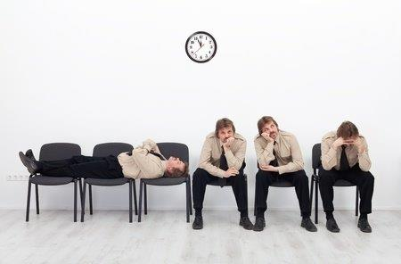  
Years ago, while working as a court services officer, I took “Ben” to visit Boys Town in Nebraska. This young man knew that his home situation was not healthy, but he was reluctant to consider a different living arrangement. When we walked into the main office of Boys Town, the receptionist bounded out from behind her desk and greeted Ben with enthusiasm. She asked about our trip, and asked if we needed anything. While she was polite to me, she maintained her attention and focus on Ben until the admissions representative joined us. The admissions representative interacted with us in the same enthusiastic manner. She was clearly prepared for our visit. She asked Ben excellent questions, and treated him as if he was the most important person in her life at that moment. We never sat in a waiting room. She simply treated Ben as if he mattered. The outcome of this visit was that Ben decided to live at Boys Town.The Boys Town receptionist and admissions representative created such a positive connection that it left a lasting impression on me. So much so, that I am writing about this experience 25 years later. Boys Town had intentionally honed the art of engagement.

"Beginning facilitators can become reactive to these early defenses. This reactivity can harm engagement efforts."

[Read more ...](https://www.familypeaceinitiative.com/blog/359-what-time-does-your-group-start-thoughts-on-engagement)

## Minimization, Denial and Blame: It is All in How We Frame It

* [Email](https://www.familypeaceinitiative.com/component/mailto/?tmpl=component&template=gantry&link=74986a3c977299bd5d4f2339aa07ccfd76548966)

Last Updated: Sunday, 24 April 2016 13:36

Written by Steve Halley

# Are ACEs Putting You At Risk?

November 15, 2018 • [Trauma Recovery & Healing](https://sisterhoodagenda.com/category/trauma-recovery-healing/), [Women's Empowerment](https://sisterhoodagenda.com/category/womens-empowerment/) • [8 Comments](https://sisterhoodagenda.com/are-aces-putting-you-at-risk/#comments)

[](https://sisterhoodagenda.com/wp-content/uploads/2018/11/kyle-broad-29486-unsplash-1024x683.jpg)

* [Author](https://sisterhoodagenda.com/are-aces-putting-you-at-risk/?gclid=EAIaIQobChMIsML1xaXW5QIVS9bACh3cgwEmEAAYASAAEgLMb_D_BwE#abh_about)
* [Recent Posts](https://sisterhoodagenda.com/are-aces-putting-you-at-risk/?gclid=EAIaIQobChMIsML1xaXW5QIVS9bACh3cgwEmEAAYASAAEgLMb_D_BwE#abh_posts)

[](https://sisterhoodagenda.com/author/sisterhood-agenda/)

### [Sisterhood Agenda](https://sisterhoodagenda.com/author/sisterhood-agenda/)

Promoting sisterhood around the globe, support and empowerment for women and girls.

#### THE CONNECTION

Women experience more trauma than men.  These traumas too often mirror the experiences of a childhood fraught with the same.  ACEs are Adverse Childhood Experiences that put all of us at risk, particularly women of color.

#### ROUGH CHILDHOODS

Why?  ACEs are traumatic experiences (for example, sexual abuse and domestic violence) that one has experienced before adulthood.  ACEs have a profound impact on self-development and womanhood.  When compared to boys, girls disproportionately experience multiple ACEs-they have more ACEs, more often and at earlier ages.

“An ACE score is a tally of different types of abuse, neglect, and other hallmarks of a rough childhood…  the rougher your childhood, the higher your score.”  [NPR](https://www.npr.org/sections/health-shots/2015/03/02/387007941/take-the-ace-quiz-and-learn-what-it-does-and-doesnt-mean)

#### FIND YOUR ACE SCORE

Are you curious and want to know more?  The first step is to find your ACE score.

#### WHAT YOUR ACE SCORE MEANS

This is a test where 10/10 is NOT a good thing.  “Points”=ACES, one point for each “Yes” answer.  A  score of 4 points means that you experienced 4 ACEs.  An ACE score of 4 or higher is considered to be a high ACE score.  A score of 7-10 is extremely high.

High ACE scores can be remarkably predictive in terms of life outcomes:  poor health and disease, emotional issues, depression, abusive relationships,  risky behavior, substance abuse and addiction, eating disorders, even future traumatic events.  All of these are predicted by high ACE scores.

Generally, as your ACE score increases, your risk for disease, social and emotional problems also increases.  Mental, physical, psychological and even spiritual development can be stunted and hindered, putting women at risk through the entire lifespan.

#### WHAT YOU CAN DO

 While it may sound like doom and gloom, unfortunately, yes, it can be.  However, it does not have to be this way.  High ACE scores do not factor in other variables that build resilience.

Resilience is a shield that strengthens holistically.

# Got Your ACE Score?

## What’s Your ACE Score? (and, at the end, What’s Your Resilience Score?)

There are 10 types of childhood trauma measured in the ACE Study. Five are personal — physical abuse, verbal abuse, sexual abuse, physical neglect, and emotional neglect. Five are related to other family members: a parent who’s an alcoholic, a mother who’s a victim of domestic violence, a family member in jail, a family member diagnosed with a mental illness, and the disappearance of a parent through divorce, death or abandonment. Each type of trauma counts as one. So a person who’s been physically abused, with one alcoholic parent, and a mother who was beaten up has an ACE score of three.

**There are, of course, many other types of childhood trauma — racism, bullying, watching a sibling being abused, losing a caregiver (grandmother, mother, grandfather, etc.), homelessness, surviving and recovering from a severe accident, witnessing a father being abused by a mother, witnessing a grandmother abusing a father, involvement with the foster care system, involvement with the juvenile justice system, etc. The ACE Study included only those 10 childhood traumas because those were mentioned as most common by a group of about 300 Kaiser members; those traumas were also well studied individually in the research literature.**

**The most important thing to remember is that the ACE score is meant as a guideline: If you experienced other types of toxic stress over months or years, then those would likely increase your risk of health consequences.**

Prior to your 18th birthday:

1. Did a parent or other adult in the household often or very often… Swear at you, insult you, put you down, or humiliate you? or Act in a way that made you afraid that you might be physically hurt?  
   No___If Yes, enter 1 ***_*_**
2. Did a parent or other adult in the household often or very often… Push, grab, slap, or throw something at you? or Ever hit you so hard that you had marks or were injured?  
   No___If Yes, enter 1 ***_*_**
3. Did an adult or person at least 5 years older than you ever… Touch or fondle you or have you touch their body in a sexual way? or Attempt or actually have oral, anal, or vaginal intercourse with you?  
   No___If Yes, enter 1 ***_*_**
4. Did you often or very often feel that … No one in your family loved you or thought you were important or special? or Your family didn’t look out for each other, feel close to each other, or support each other?  
   No___If Yes, enter 1 ***_*_**
5. Did you often or very often feel that … You didn’t have enough to eat, had to wear dirty clothes, and had no one to protect you? or Your parents were too drunk or high to take care of you or take you to the doctor if you needed it?  
   No___If Yes, enter 1 ***_*_**
6. Were your parents ever separated or divorced?  
   No___If Yes, enter 1 ***_*_**
7. Was your mother or stepmother:  
   Often or very often pushed, grabbed, slapped, or had something thrown at her? or Sometimes, often, or very often kicked, bitten, hit with a fist, or hit with something hard? or Ever repeatedly hit over at least a few minutes or threatened with a gun or knife?  
   No___If Yes, enter 1 ***_*_**
8. Did you live with anyone who was a problem drinker or alcoholic, or who used street drugs?  
   No___If Yes, enter 1 ***_*_**
9. Was a household member depressed or mentally ill, or did a household member attempt suicide?                        No___If Yes, enter 1 ***_*_**
10. Did a household member go to prison?  
    No___If Yes, enter 1 ***_*_**

Now add up your “Yes” answers: ***_*** This is your ACE Score

# The Adverse Childhood Experiences Study — the largest, most important public health study you never heard of — began in an obesity clinic

[October 3, 2012](https://acestoohigh.com/2012/10/03/the-adverse-childhood-experiences-study-the-largest-most-important-public-health-study-you-never-heard-of-began-in-an-obesity-clinic/) By [Jane Ellen Stevens](https://acestoohigh.com/author/jestevens/) in [ACE Study](https://acestoohigh.com/category/ace-study/), [Child abuse](https://acestoohigh.com/category/child-abuse/), [Child trauma](https://acestoohigh.com/category/child-trauma/), [Chronic disease](https://acestoohigh.com/category/chronic-disease/), [Neurobiology](https://acestoohigh.com/category/neurobiology/) [292 Comments](https://acestoohigh.com/2012/10/03/the-adverse-childhood-experiences-study-the-largest-most-important-public-health-study-you-never-heard-of-began-in-an-obesity-clinic/#comments)

Mentions of the ACE Study – the CDC’s Adverse Childhood Experiences Study — have shown up in the [*New York Times*](http://www.nytimes.com/2012/09/28/opinion/brooks-the-psych-approach.html), [*This American Life*](http://www.thisamericanlife.org/radio-archives/episode/474/back-to-school), and [*Salon.com*](http://salon.com/) recently. In the last year, it’s become a buzzword in social services, public health, education, juvenile justice, mental health, pediatrics, criminal justice and even business. Many people say that just as everyone should be aware of her or his cholesterol score, so [*should everyone know her or his ACE score*](https://acestoohigh.com/got-your-ace-score/). But what is this study? And why is it so important to, well, almost everyone in 2012, the same way polio became important to almost everyone in the 1950s? Here’s the backstory.

The ACE Study – probably the most important public health study you never heard of – had its origins in an obesity clinic on a quiet street in San Diego.

It was 1985, and Dr. Vincent Felitti was mystified. The physician, chief of Kaiser Permanente’s revolutionary Department of Preventive Medicine in San Diego, CA, couldn’t figure out why, each year for the last five

years, more than half of the people in his obesity clinic dropped out. Although people who wanted to shed as little as 30 pounds could participate, the clinic was designed for people who were 100 to 600 pounds overweight.

Felitti cut an imposing, yet dashing, figure. Tall, straight-backed, not a silver hair out of place, penetrating eyes, he was a doctor whom patients trusted implicitly, spoke of reverentially and rarely called by his first name. The preventive medicine department he created had become an international beacon for efficient and compassionate care. Every year, more than 50,000 people were screened for diseases that tests and machines could pick up before symptoms appeared. It was the largest medical evaluation site in the world. It was reducing health care costs before reducing health care costs was cool.

[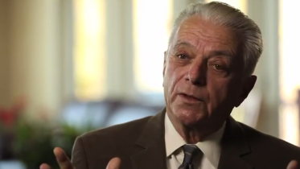](https://acestoohigh.files.wordpress.com/2012/10/avafelitti.png)

Dr. Vincent Felitti

But the 50-percent dropout rate in the obesity clinic that Felitti started in 1980 was driving him crazy. A cursory review of all the dropouts’ records astonished him — they’d all been losing weight when they left the program, not gaining. That made no sense whatsoever. Why would people who were 300 pounds overweight lose 100 pounds, and then drop out when they were on a roll?

The situation “was ruining my attempts to build a successful program,” he recalls, and in typical Type-A fashion, he was determined to find out why.

The mystery turned into a 25-year quest involving researchers from the Centers for Disease Control and Prevention and more than 17,000 members of Kaiser Permanente’s San Diego care program. It would reveal that adverse experiences in childhood were very common, even in the white middle-class, and that these experiences are linked to every major chronic illness and social problem that the United States grapples with – and spends billions of dollars on.

But in 1985, all that Felitti knew was that the obesity clinic had a serious problem. He decided to dig deep into the dropouts’ medical records. This revealed a couple of surprises: All the dropouts had been born at a normal weight. They didn’t gain weight slowly over several years.

“I had assumed that people who were 400, 500, 600 pounds would be getting heavier and heavier year after year. In 2,000 people, I did not see it once,” says Felitti. When they gained weight, it was abrupt and then they stabilized. If they lost weight, they regained all of it or more over a very short time.

But this knowledge brought him no closer to solving the mystery. So, he decided to do face-to-face interviews with a couple hundred of the dropouts. He used a standard set of questions for everyone. For weeks, nothing unusual came of the inquiries. No revelations. No clues.

The turning point in Felitti’s quest came by accident. The physician was running through yet another series of questions with yet another obesity program patient: How much did you weigh when you were born? How much did you weigh when you started first grade? How much did you weigh when you entered high school? How old were you when you became sexually active? How old were you when you married?

“I misspoke,” he recalls, probably out of discomfort in asking about when she became sexually active – although physicians are given plenty of training in examining body parts without hesitation, they’re given little support in talking about what patients do with some of those body parts. “Instead of asking, “How old were you when you were first sexually active,” I asked, “How much did you weigh when you were first sexually active?’ The patient, a woman, answered, ‘Forty pounds.’”

He didn’t understand what he was hearing. He misspoke the question again. She gave the same answer, burst into tears and added, “It was when I was four years old, with my father.”

He suddenly realized what he had asked.

“I remembered thinking, ‘This is only the second incest case I’ve had in 23 years of practice’,” Felitti recalls. “I didn’t know what to do with the information. About 10 days later, I ran into the same thing. It was very disturbing. Every other person was providing information about childhood sexual abuse. I thought, ‘This can’t be true. People would know if that were true. Someone would have told me in medical school.’ ”

Worried that he was injecting some unconscious bias into the questioning, he asked five of his colleagues to interview the next 100 patients in the weight program. “They turned up the same things,” he says.

Of the 286 people whom Felitti and his colleagues interviewed, most had been sexually abused as children. As startling as this was, it turned out to be less significant than another piece of the puzzle that dropped into place during an interview with a woman who had been raped when she was 23 years old. In the year after the attack, she told Felitti that she’d gained 105 pounds.

“As she was thanking me for asking the question,” says Felitti, “she looks down at the carpet, and mutters, ‘Overweight is overlooked, and that’s the way I need to be.’”

During that encounter, a realization struck Felitti. It’s a significant detail that many physicians, psychologists, public health experts and policymakers haven’t yet grasped: The obese people that Felitti was interviewing were 100, 200, 300, 400 overweight, but they didn’t see their weight as a problem. To them, eating was a fix, a solution. (There’s a reason an IV drug user calls a dose a “fix”.)

One way it was a solution is that it made them feel better. Eating soothed their anxiety, fear, anger or depression – it worked like alcohol or tobacco or methamphetamines. Not eating increased their anxiety, depression, and fear to levels that were intolerable.

The other way it helped was that, for many people, just being obese solved a problem. In the case of the woman who’d been raped, she felt as if she were invisible to men. In the case of a man who’d been beaten up when he was a skinny kid, being fat kept him safe, because when he gained a lot of weight, nobody bothered him. In the case of another woman — whose father told her while he was raping her when she was 7 years old that the only reason he wasn’t doing the same to her 9-year-old sister was because she was fat — being obese protected her. Losing weight increased their anxiety, depression, and fear to levels that were intolerable.

For some people, both motivations were in play.

Felitti didn’t know this at the time, but this was the more important result — the mind-shift, the new meme that would begin spreading far beyond a weight clinic in San Diego. It would provide more understanding about the lives of hundreds of millions of people around the world who use biochemical coping methods – such as alcohol, marijuana, food, sex, tobacco, violence, work, methamphetamines, thrill sports – to escape intense fear, anxiety, depression, anger.

Public health experts, social service workers, educators, therapists and policy makers commonly regard addiction as a problem. Some, however, are beginning to grasp that turning to drugs is a normal response to serious childhood trauma, and that telling people who smoke or overeat or overwork that these are bad for them and that they should stop doesn’t register when those approaches provide a temporary, but gratifying solution.

Ella Herman was one of the people who participated in the obesity clinic, but had dropped out because any weight she lost, she regained. Herman owned a successful childcare center in San Diego. Herman said she was sexually abused by two uncles and a school bus driver; the first time occurred when she was four years old. She married a man who abused her repeatedly and tried to kill her. With the help of her family, she fled with her children to San Diego, where she later remarried.

“I imagine I’ve lost 100 pounds about six times,” she recalled. “And gained it back.” Every time she lost weight and a man commented on her beauty, she became terrified and began eating. But she never understood the connection until she attended a meeting at which Felitti talked about what he’d learned from patients. At this time, Herman was just over five feet tall and weighed nearly 300 pounds. “He had a room full of people,” she said. “The more he talked the more I cried, because he was touching every aspect of my life. Somebody in the world understands, I thought.”

Herman later sent a letter to Felitti. “I want to thank you for caring enough about people to read all those charts and finding out what happens to all of us who are molested, raped and abused in childhood,” she wrote. “…I suffered for years. The pain became so great I was thinking of jumping off the San Diego Bay Bridge….How many people may have taken their life because they had no program to turn to? How many lives can be saved by this program?”

**What do you do when you’ve got something important to tell the world, but the world thinks it’s stupid?**

So, if you were Vincent Felitti, whom would you pick as your first audience to reveal your stunning findings? A group relatively informed about obesity that would greet the new information with extreme interest, praise and applause? Natch. So, in 1990, Felitti flew to Atlanta to give a speech to the members – many of them psychologists and psychiatrists — of the North American Association for the Study of Obesity. The audience listened quietly and politely. When he finished, one of the experts stood up and blasted him. “He told me I was naïve to believe my patients, that it was commonly understood by those more familiar with such matters that these patient statements were fabrications to provide a cover explanation for failed lives!”

At dinner, Dr. David Williamson, an epidemiologist from the U.S. Centers for Disease Control and Prevention, sat next to the perplexed Felitti. Williamson was intrigued. He leaned over and “told me that people could always find fault with a study of a couple of hundred people,” says Felitti, “but not if there were thousands, and from a general population, not a subset like an obesity program. I turned to him and said, ‘That’s not a problem.’ ”

[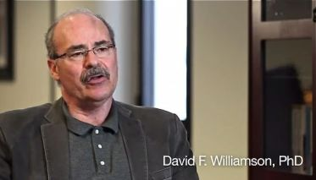](https://acestoohigh.files.wordpress.com/2012/10/avawilliamson.jpg)

Williamson invited Felitti to meet with a small group of researchers at the Centers for Disease Control. Dr. Robert Anda, a medical epidemiologist was among them. If Felitti is the model for a TV show featuring a wise and stately chief physician who sits straight, stands straight, and keeps his personal feelings in check, Anda would be the dashing, young, brilliant researcher who wears his tie askew, slumps in chairs, laughs easily, loves to joke around, and puts his heart on his sleeve for all to see.

Anda began his career as a physician, but became intrigued with epidemiology and public health. When he met Felitti, he had been studying how depression and feelings of hopelessness affect coronary heart disease. He noticed that depression and hopelessness weren’t random. “I became interested in going deeper, because I thought that there must be something beneath the behaviors that were generating them,” says Anda.

Kaiser Permanente in San Diego was a perfect place to do a mega-study. More than 50,000 members came through the department each year, for a comprehensive medical evaluation. Every person who came through the Department of Preventive Medicine filled out a detailed biopsychosocial (biomedical, psychological, social) medical questionnaire prior to undergoing a complete physical examination and extensive laboratory tests. It would be easy to add another set of questions. In two waves, Felitti and Anda asked 26,000 people who came through the department “if they would be interested in helping us understand how childhood events might affect adult health,” says Felitti. Of those, 17,421 agreed.

Before they added the new trauma-oriented questions, Anda spent a year pouring through the research literature to learn about childhood trauma, and focused on the eight major types that patients had mentioned so often in Felitti’s original study and whose individual consequences had been studied by other researchers. These eight included three types of abuse — sexual, verbal and physical. And five types of family dysfunction — a parent who’s mentally ill or alcoholic, a mother who’s a domestic violence victim, a family member who’s been incarcerated, a loss of a parent through divorce or abandonment. He later added emotional and physical neglect, for a total of 10 types of adverse childhood experiences, or ACEs.

[](https://acestoohigh.files.wordpress.com/2012/10/avaanda.jpg)

The initial surveys began in 1995 and continued through 1997, with the participants followed subsequently for more than fifteen years. “Everything we’ve published comes from that baseline survey of 17,421 people,” says Anda, as well as what was learned by following those people for so long.

When the first results of the survey were due to come in, Anda was at home in Atlanta. Late in the evening, he logged into his computer to look at the findings. He was stunned. “I wept,” he says. “I saw how much people had suffered and I wept.”

This was the first time that researchers had looked at the effects of several types of trauma, rather than the consequences of just one. What the data revealed was mind-boggling.

The first shocker: There was a direct link between childhood trauma and adult onset of chronic disease, as well as mental illness, doing time in prison, and work issues, such as absenteeism.

The second shocker: About two-thirds of the adults in the study had experienced one or more types of adverse childhood experiences. Of those, 87 percent had experienced 2 or more types. This showed that people who had an alcoholic father, for example, were likely to have also experienced physical abuse or verbal abuse. In other words, ACEs usually didn’t happen in isolation.

The third shocker: More adverse childhood experiences resulted in a higher risk of medical, mental and social problems as an adult.

[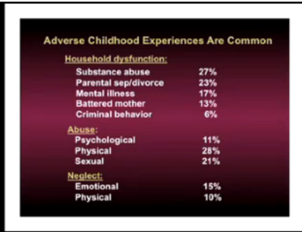](https://acestoohigh.files.wordpress.com/2012/10/aceslist.png)

To explain this, Anda and Felitti developed [a scoring system for ACEs](https://acestoohigh.com/got-your-ace-score/). Each type of adverse childhood experience counted as one point. If a person had none of the events in her or his background, the ACE score was zero. If someone was verbally abused thousands of times during his or her childhood, but no other types of childhood trauma occurred, this counted as one point in the ACE score. If a person experienced verbal abuse, lived with a mentally ill mother and an alcoholic father, his ACE score was three.

Things start getting serious around an ACE score of 4. Compared with people with zero ACEs, those with four categories of ACEs had a 240 percent greater risk of hepatitis, were 390 percent more likely to have chronic obstructive pulmonary disease (emphysema or chronic bronchitis), and a 240 percent higher risk of a sexually-transmitted disease.

[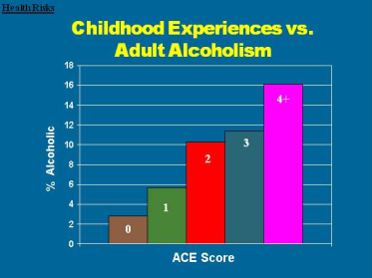](https://acestoohigh.files.wordpress.com/2012/10/acealcoholism.png)

They were twice as likely to be smokers, 12 times more likely to have attempted suicide, seven times more likely to be alcoholic, and 10 times more likely to have injected street drugs.

People with high ACE scores are more likely to be violent, to have more marriages, more broken bones, more drug prescriptions, more depression, more auto-immune diseases, and more work absences.

[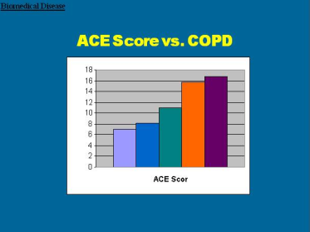](https://acestoohigh.files.wordpress.com/2012/10/acecopd.png)

“Some of the increases are enormous and are of a size that you rarely ever see in health studies or epidemiological studies. It changed my thinking dramatically,” says Anda.

[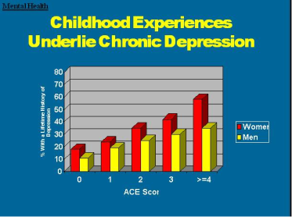](https://acestoohigh.files.wordpress.com/2012/10/acedepression.png)

Two in nine people had an ACE score of 3 or more, and one in eight had an ACE score of 4 or more. This means that every physician probably sees several high ACE score patients every day, notes Felitti. “Typically, they are the most difficult, though the underpinnings will rarely be recognized.”

The kicker was this: The ACE Study participants were average Americans. Seventy-five percent were white, 11 percent Latino, 7.5 percent Asian and Pacific Islander, and 5  percent were black. They were middle-class, middle-aged, 36 percent had attended college and 40 percent had college degrees or higher. Since they were members of Kaiser Permanente, they all had jobs and great health care. Their average age was 57.

As Anda has said: “It’s not just ‘them’. It’s us.”

**Changing the landscape of understanding human development**

In the last 14 years, Anda, Felitti and other CDC researchers have published more than 60 papers in prestigious peer-reviewed journals, including the Journal of the American Medical Association and the American Journal of Preventive Medicine. Other researchers have referenced their work more than 1,500 times. Anda and Felitti have flown around the U.S., Canada and Europe to give hundreds of speeches.

Their inquiry “changed the landscape,” says Dr. Frank Putnam, director of the [Mayerson Center for Safe and Healthy Children](http://www.cincinnatichildrens.org/research/divisions/m/mayerson/default/) at Cincinnati Children’s Hospital Medical Center and professor at the University of Cincinnati Department of Pediatrics. “It changed the landscape because of the pervasiveness of ACEs in the huge number of public health problems, expensive public health problems — depression, substance abuse, STDs, cancer, heart disease, chronic lung disease, diabetes.”

**Now that you’ve got your ACE score, what does it mean?**

First….a tiny bit of background to help you figure this out…..(if you want the back story about the fascinating origins of the ACE Study, read [The Adverse Childhood Experiences Study — the largest, most important public health study you never heard of — began in an obesity clinic.](https://acestoohigh.com/2012/10/03/the-adverse-childhood-experiences-study-the-largest-most-important-public-health-study-you-never-heard-of-began-in-an-obesity-clinic/))

The CDC’s Adverse Childhood Experiences Study ([ACE Study](http://www.cdc.gov/ace/index.htm)) [uncovered](http://www.cdc.gov/ace/findings.htm) a stunning link between childhood trauma and the chronic diseases people develop as adults, as well as social and emotional problems. This [includes](http://www.newyorker.com/reporting/2011/03/21/110321fa_fact_tough) heart disease, lung cancer, diabetes and many autoimmune diseases, as well as depression, violence, being a victim of violence, and suicide.

The first research results [were published in 1998, followed by more than 70 other publications through 2015](https://acestoohigh.com/research/). They showed that:

* childhood trauma was very common, even in employed white middle-class, college-educated people with great health insurance;
* there was a direct link between childhood trauma and adult onset of chronic disease, as well as depression, suicide, being violent and a victim of violence;
* more types of trauma increased the risk of health, social and emotional problems.
* people usually experience more than one type of trauma – rarely is it only sex abuse or only verbal abuse.

A whopping two thirds of the 17,000 people in the ACE Study had an ACE score of at least one —[87 percent of those](http://www.acestudy.org/yahoo_site_admin/assets/docs/ARV1N1.127150541.pdf) had more than one. Thirty-six states and the District of Columbia have done their own ACE surveys; their results are similar to the CDC’s ACE Study.

[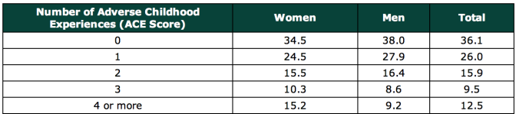](https://acestoohigh.files.wordpress.com/2011/11/acescores.png)

The study’s researchers came up with an ACE score to explain a person’s risk for chronic disease. Think of it as a cholesterol score for childhood toxic stress. You get one point for each type of trauma. The higher your ACE score, the higher your risk of health and social problems. (Of course, other types of trauma exist that could contribute to an ACE score, so it is conceivable that people could have ACE scores higher than 10; however, the ACE Study measured only 10 types.)

As your ACE score increases, so does the risk of disease, social and emotional problems. With an ACE score of 4 or more, things start getting serious. The likelihood of chronic pulmonary lung disease [increases](https://acestoohigh.com/category/ace-study/) 390 percent; hepatitis, 240 percent; depression 460 percent; attempted suicide, 1,220 percent.

(By the way, lest you think that the ACE Study was yet another involving inner-city poor people of color, take note: The study’s participants were 17,000 mostly white, middle and upper-middle class college-educated San Diegans with good jobs and great health care – they all belonged to the Kaiser Permanente health maintenance organization.)

[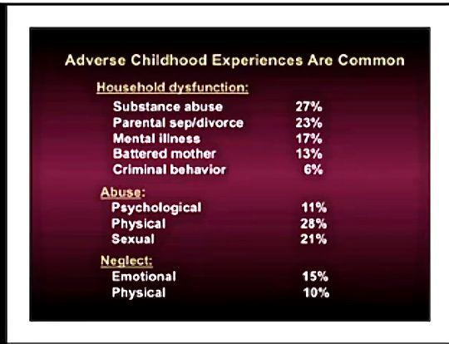](https://acestoohigh.files.wordpress.com/2011/11/aceslist1.jpg)

Here are some specific graphic examples of how increasing ACE scores increase the risk of some diseases, social and emotional problems. All of these graphs come from “The relationship of adverse childhood experiences to adult health, well being, social function and health care”, a book chapter by Drs. Vincent Felitti and Robert Anda, co-founders of the ACE Study, in [“The Hidden Epidemic: The Impact of Early Life Trauma on Health and Disease.”](http://www.cambridge.org/gb/knowledge/isbn/item2709685/?site_locale=en_GB)

[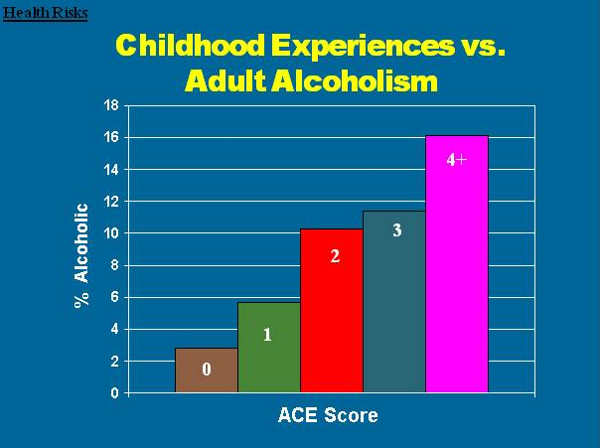](https://acestoohigh.files.wordpress.com/2011/11/acealcoholism.png)

[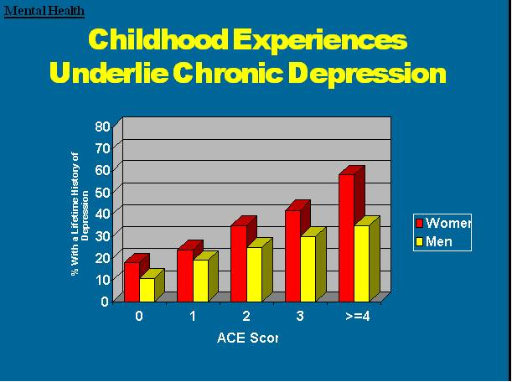](https://acestoohigh.files.wordpress.com/2011/11/acedepression.png)

**[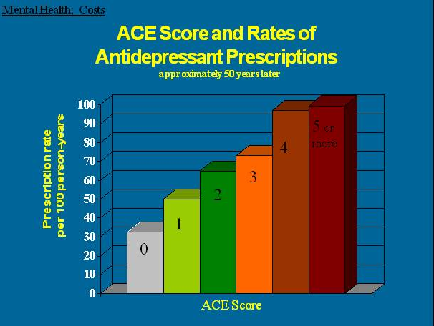](https://acestoohigh.files.wordpress.com/2011/11/aceantidepresspresc.png)**

**[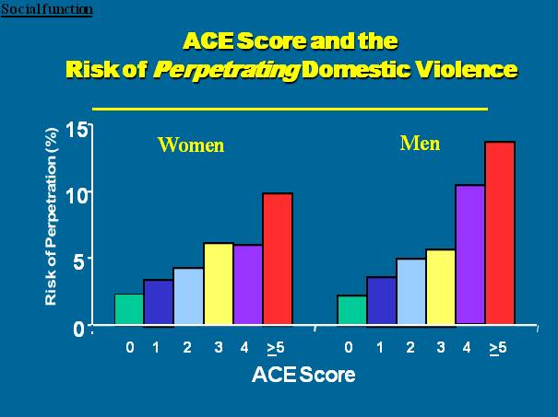](https://acestoohigh.files.wordpress.com/2011/11/acedodv.png)**

**[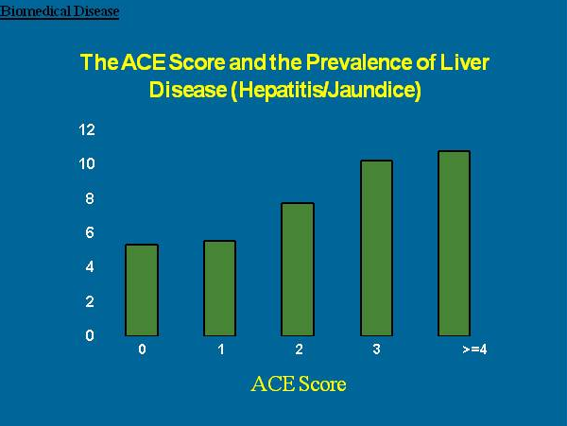](https://acestoohigh.files.wordpress.com/2011/11/aceliverdisease1.png)**

**[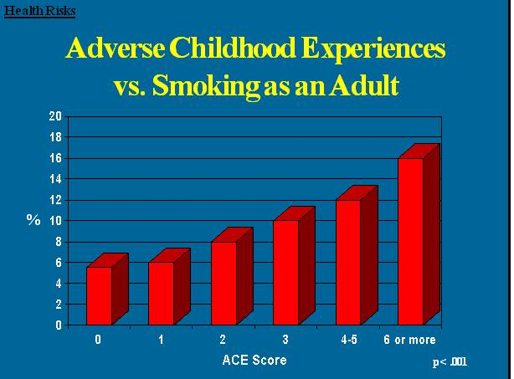](https://acestoohigh.files.wordpress.com/2011/11/acesmoking.png)**

**[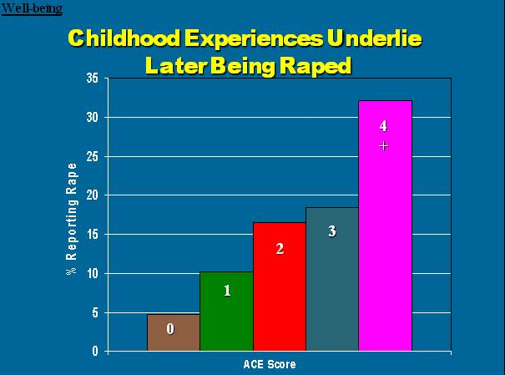](https://acestoohigh.files.wordpress.com/2011/11/aceraped.png)**

[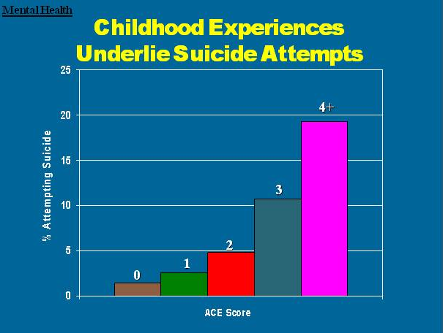](https://acestoohigh.files.wordpress.com/2011/11/acesuicideattempts.png)

[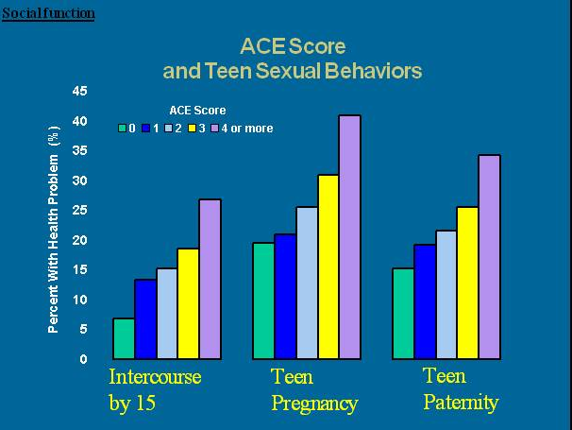](https://acestoohigh.files.wordpress.com/2011/11/acesexbehaviors.png)

[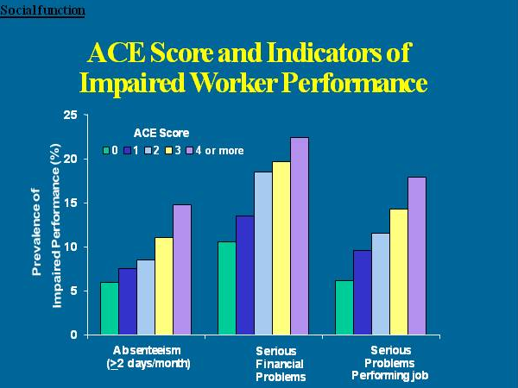](https://acestoohigh.files.wordpress.com/2011/11/aceworker.png)

**[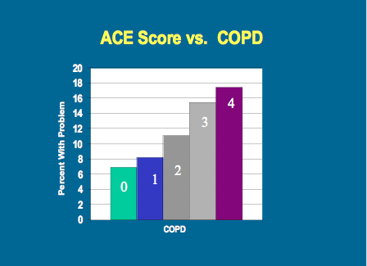](https://acestoohigh.files.wordpress.com/2011/11/acescopd.png)**

**What causes this?**

At the same time that the ACE Study was being done, parallel research on kids’ brains found that [toxic stress damages the structure and function of a child’s developing brain.](http://developingchild.harvard.edu/) This was determined by a group of neuroscientists and pediatricians, including neuroscientist [Martin Teicher](http://www.mclean.harvard.edu/about/bios/detail.php?username=mteicher) and pediatrician [Jack Shonkoff](http://developingchild.harvard.edu/about/center_director_and_staff/#Shonkoff), both at Harvard University, neuroscientist [Bruce McEwen](http://www.rockefeller.edu/research/faculty/abstract.php?id=109) at Rockefeller University, and child psychiatrist Bruce Perry at the [Child Trauma Academy](http://www.childtrauma.org/).

When children are overloaded with stress hormones, they’re in flight, fright or freeze mode. They can’t learn in school. They often have difficulty trusting adults or developing healthy relationships with peers (i.e., they become loners). To relieve their anxiety, depression, guilt, shame, and/or inability to focus, they turn to easily available biochemical solutions — nicotine, alcohol, marijuana, methamphetamine — or activities in which they can escape their problems — high-risk sports, proliferation of sex partners, and work/over-achievement. (e.g. Nicotine reduces anger, increases focus and relieves depression. Alcohol relieves stress.)

Using drugs or overeating or engaging in risky behavior leads to consequences as a direct result of this behavior. For example, smoking can lead to COPD (chronic obstructive pulmonary disease) or lung cancer. Overeating can lead to obesity and diabetes. In addition, there is increasing research that shows that severe and chronic stress leads to bodily systems producing an inflammatory response that leads to disease.

In addition, toxic stress can be passed down from generation to generation. The field of epigenetics shows that we are born with a set of genes that can be turned on and off, depending on what’s happening in our environment. If a child grows up with an overload of toxic stress, their stress-response genes are likely to be activated so that they are easily triggered by stressful situations that don’t affect those who don’t grow up with toxic stress. They can pass that response onto their children.

Fortunately, brains and lives are somewhat plastic. Resilience research shows that the appropriate integration of resilience factors — such as asking for help, developing trusting relationships, forming a positive attitude, listening to feelings — can help people improve their lives.

For more information about ACEs science and how it’s being used, go to: [ACEs Science 101.](https://acestoohigh.com/aces-101/)

For more information about the ACE Study, check out the [CDC’s ACE Study site](http://www.cdc.gov/ace/index.htm).

Here’s a link to the[long questionnaire (200+ questions)](http://www.cdc.gov/ace/questionnaires.htm).

For more information about ACEs science, go to [ACEs Science 101](https://acestoohigh.com/aces-101/).

_______________________

**What’s Your Resilience Score?**

This questionnaire was developed by the early childhood service providers, pediatricians, psychologists, and health advocates of Southern Kennebec Healthy Start, Augusta, Maine, in 2006, and updated in February 2013. Two psychologists in the group, Mark Rains and Kate McClinn, came up with the 14 statements with editing suggestions by the other members of the group. The scoring system was modeled after the ACE Study questions. The content of the questions was based on a number of research studies from the literature over the past 40 years including that of Emmy Werner and others. Its purpose is limited to parenting education. It was not developed for research.

Rains wants everyone to know that the resilience questions are only meant to prompt reflection and conversation on experiences that may help protect most people (about three out of four) with four or more ACEs from developing negative outcomes. A secure early childhood is helpful, but not necessary. A higher number of positive experiences is not necessarily more protective. He regrets that the questions have taken on a life of their own and that people may have misinterpretted or misunderstood their experience of risk and resilience, based on the ACE or “Resilience” questionnaires. For more information, he suggests reading this article on ACEs Too High — [Putting resilience and resilience surveys under the microscope](https://acestoohigh.com/2017/02/05/__trashed-4/).

**RESILIENCE Questionnaire**

**Please circle the most accurate answer under each statement:**

**1.  I believe that my mother loved me when I was little.**

Definitely true         Probably true         Not sure         Probably Not True        Definitely Not True

**2.  I believe that my father loved me when I was little.**

Definitely true         Probably true         Not sure         Probably Not True        Definitely Not True

**3.  When I was little, other people helped my mother and father take care of me and they seemed to love me.**

Definitely true         Probably true         Not sure         Probably Not True        Definitely Not True

**4.   I’ve heard that when I was an infant someone in my family enjoyed playing with me, and I enjoyed it, too.**

Definitely true         Probably true         Not sure         Probably Not True        Definitely Not True

**5.  When I was a child, there were relatives in my family who made me feel better if I was sad or worried.**

Definitely true         Probably true         Not sure         Probably Not True        Definitely Not True

**6.   When I was a child, neighbors or my friends’ parents seemed to like me.**

Definitely true         Probably true         Not sure         Probably Not True        Definitely Not True

**7.  When I was a child, teachers, coaches, youth leaders or ministers were there to help me.**

Definitely true         Probably true         Not sure         Probably Not True        Definitely Not True

**8.  Someone in my family cared about how I was doing in school.**

Definitely true         Probably true         Not sure         Probably Not True        Definitely Not True

**9.  My family, neighbors and friends talked often about making our lives better.**

Definitely true         Probably true         Not sure         Probably Not True        Definitely Not True

**10.  We had rules in our house and were expected to keep them.**

Definitely true         Probably true         Not sure         Probably Not True        Definitely Not True

**11. When I felt really bad, I could almost always find someone I trusted to talk to.**

Definitely true         Probably true         Not sure         Probably Not True        Definitely Not True

**12.  As a youth, people noticed that I was capable and could get things done.**

Definitely true         Probably true         Not sure         Probably Not True        Definitely Not True

**13.  I was independent and a go-getter.**

Definitely true         Probably true         Not sure         Probably Not True        Definitely Not True

**14.  I believed that life is what you make it.**

Definitely true         Probably true         Not sure         Probably Not True        Definitely Not True

How many of these 14 protective factors did I have as a child and youth? (How many of the 14 were circled “Definitely True” or “Probably True”?)   _______

Of these circled, how many are still true for me? _______

So, you've got your score. Now what?

First, remember that the ACE score isn't a crystal ball; it's just meant as guidance. It tells you about one type of risk factor among many. It doesn't directly take into account your diet or genes, or whether you smoke or drink excessively — to name just a few of the other major influences on health.

[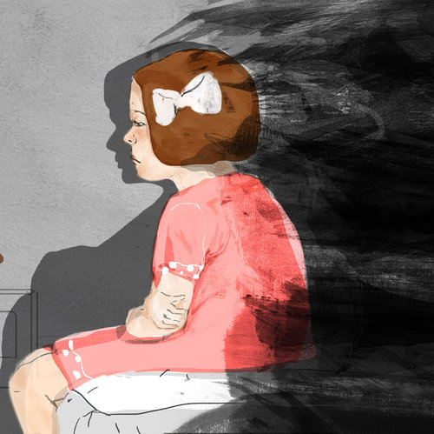](https://www.npr.org/sections/health-shots/2015/03/02/377569413/can-family-secrets-make-you-sick)

### [Shots - Health News](https://www.npr.org/sections/health-shots/)

### [Can Family Secrets Make You Sick?](https://www.npr.org/sections/health-shots/2015/03/02/377569413/can-family-secrets-make-you-sick)

[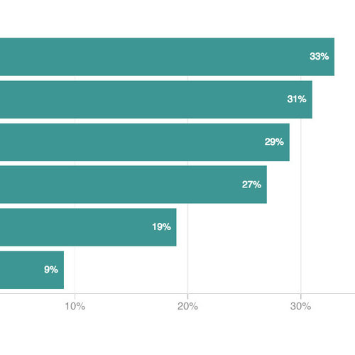](https://www.npr.org/sections/health-shots/2015/03/02/388994897/poll-finds-factors-large-and-small-shape-peoples-health)

### [Shots - Health News](https://www.npr.org/sections/health-shots/)

### [Poll Explores Our Perception Of How Factors Large And Small Shape People's Health](https://www.npr.org/sections/health-shots/2015/03/02/388994897/poll-finds-factors-large-and-small-shape-peoples-health)

To learn more, check the [CDC's ACE Study website](https://www.cdc.gov/violenceprevention/acestudy/index.html). You'll find, among other things, a [list of studies](https://www.cdc.gov/violenceprevention/acestudy/journal.html) that explore the ways adverse childhood experiences have been linked to a variety of adult conditions, ranging from increased headaches to depression to heart disease.

Remember this, too: ACE scores don't tally the positive experiences in early life that can help build resilience and protect a child from the effects of trauma. Having a grandparent who loves you, a teacher who understands and believes in you, or a trusted friend you can confide in may mitigate the long-term effects of early trauma, psychologists say.

"There are people with high ACE scores who do remarkably well," says Jack Shonkoff, a pediatrician and director of the Center on the Developing Child at Harvard University.

Resilience, he says, builds throughout life, and close relationships are key. Recent [research](http://www.ncbi.nlm.nih.gov/pubmed/25084563) also suggests that for adults, "trauma informed" therapy — which can center on art, yoga or mindfulness training — can help.

### Three Types of ACEs

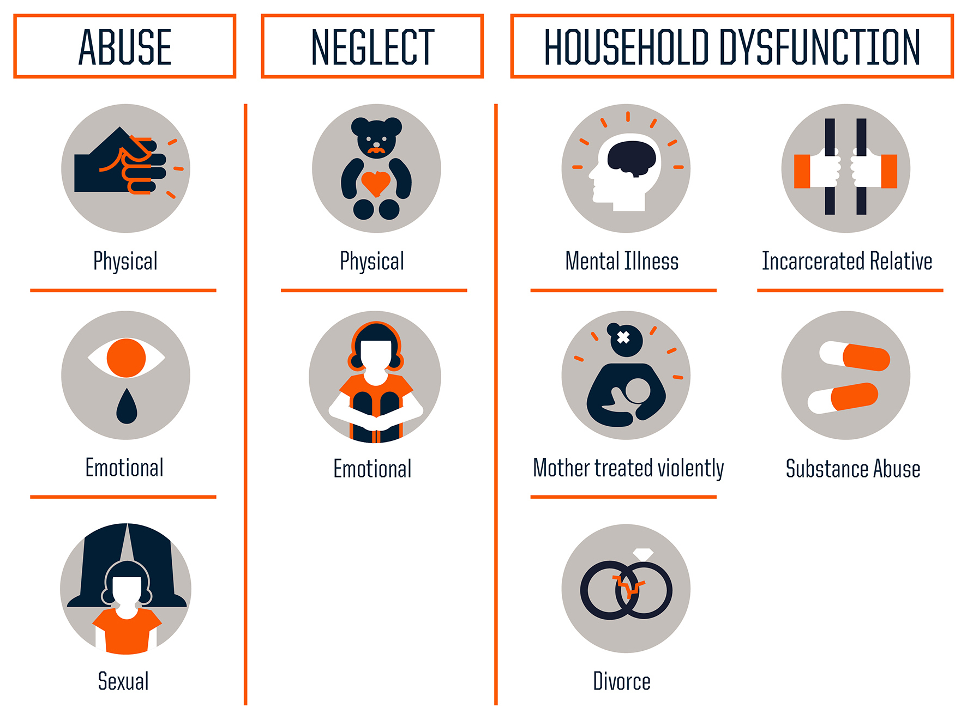

Source: Centers for Disease Control and Prevention

Credit: Robert Wood Johnson Foundation

How best to find and help kids who are experiencing abuse and neglect right now?

Child psychologist [Hilit Kletter](https://med.stanford.edu/profiles/hilit-kletter), of Stanford University's School of Medicine, says that to spot these children, she looks for visible signs of stress to understand what might have happened to them and how best to intervene. Some kids have nightmares or recurring thoughts of a stressful event, she says, or may re-enact the trauma through play. Or the child may seem distracted or withdrawn.

"This will come out at school," Kletter says. "Teachers will tell parents [their child] seems to be in a daze in the classroom, not paying attention."

### ACEs Increase Health Risks

According to the Adverse Childhood Experiences study, the rougher your childhood, the higher your score is likely to be and the higher your risk for various health problems later.

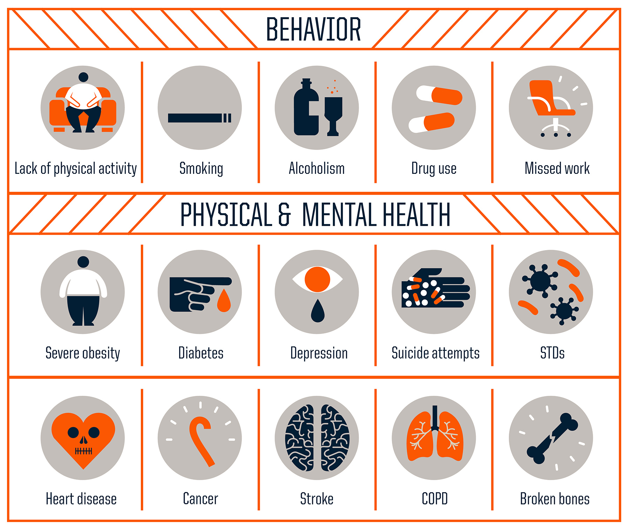

Source: Centers for Disease Control and Prevention

Credit: Robert Wood Johnson Foundation

Kletter says reactions to trauma are sometimes misdiagnosed as symptoms of attention deficit hyperactivity disorder, because kids dealing with adverse experiences may be impulsive — acting out with anger or other strong emotions.

"It's something that's very common in trauma: difficulty in regulating emotions and behavior," she explains. "That's why a lot of these kids get in trouble with the classroom."

[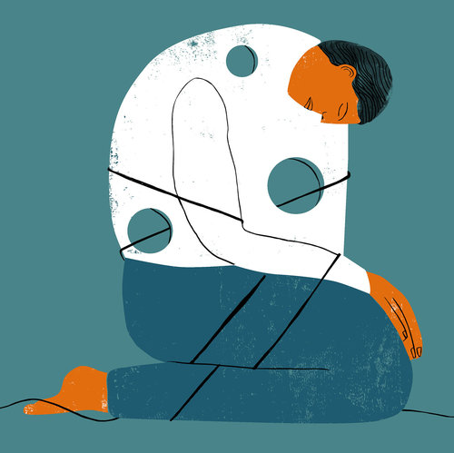](https://www.npr.org/sections/health-shots/2015/03/02/389347123/people-with-low-incomes-say-they-pay-a-price-in-poor-health)

### [Shots - Health News](https://www.npr.org/sections/health-shots/)

### [People With Low Incomes Say They Pay A Price In Poor Health](https://www.npr.org/sections/health-shots/2015/03/02/389347123/people-with-low-incomes-say-they-pay-a-price-in-poor-health)

Shonkoff's research center at Harvard tests interventions that can [build resilience in kids](http://pediatrics.aappublications.org/content/early/2014/06/10/peds.2013-2475.abstract?sid=0efeb078-1ed5-41b0-ba61-8fa71ad359c1) who are growing up with adverse experiences — not just problems in the family, such as those the ACE study investigated, but also trauma stemming from poverty, for example, or from the chronic stress of racial or gender discrimination.

To bolster parents, the Harvard team is testing interventions right now that use video coaching to show moms and dads how to engage their babbling infants, using sounds and facial expressions in a style Shonkoff calls [serve and return](http://developingchild.harvard.edu/resources/multimedia/videos/three_core_concepts/serve_and_return/).

Shonkoff says these early interactions — a kind of conversation — have been shown to help children with later learning and literacy. Even more important, they boost kids' resilience, by helping them build secure attachments with caring adults. Research suggests that [just one](http://www.ncbi.nlm.nih.gov/pubmed/17347353) caring, safe relationship early in life gives any child a much better shot at growing up healthy.

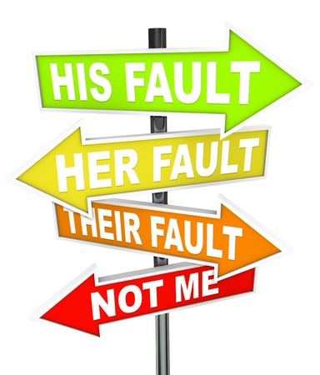

One of the first concepts that most of us learn when we are training to facilitate BIP groups is the need to address minimization, denial and blame. We learn that those who batter will use these tactics in order to avoid responsibility for their behavior, and they sure do. We are taught to challenge these tactics when they arise in group conversation, and focus on the dysfunction of using these tactics to escape responsibility. While bringing their attention to these behaviors is valuable, how we frame our response is crucial.

Has it ever occurred to you that perhaps our participants’ use of minimization, denial and blame is a positive indicator of awareness of their behavior being wrong? If they were not aware on some level of their behavior being “out of bounds”, they would not need the benefit of these tactics. If this is contrary to how you have approached this challenging issue in your group, please allow me to explain.

“…our participants’ use of minimization, denial and blame is a positive indicator of awareness of their behavior being wrong.”

[Read more ...](https://www.familypeaceinitiative.com/blog/357-minimization-denial-and-blame-it-is-all-in-how-we-frame-it)

## Getting to Ownership: The Value of Making a List

* [Email](https://www.familypeaceinitiative.com/component/mailto/?tmpl=component&template=gantry&link=57cb7b2b6e17ad96d55f312ad6886a9ee841a531)

Last Updated: Sunday, 24 April 2016 13:35

Written by Steve Halley



Facilitating a domestic violence intervention group comes with many unique challenges. Accountability and ownership are key components to a BIP class, but it can be challenging to find a healthy balance between these while simultaneously maintaining a positive relationship.  How to help participants take responsibility for their behaviors quickly and safely without  sacrificing emotional safety can be a challenge for even the most seasoned facilitator.

Here at the Family Peace Initiative, we love to make lists. We have found that the simple act of “list making” can open doors to the ownership of behavior that can otherwise be challenging to open.  Here is how we do it:

[Read more ...](https://www.familypeaceinitiative.com/blog/356-getting-to-ownership-the-value-of-making-a-list)

Top of Form

Bottom of Form

Top of Form

Bottom of Form